Lab 1583-K23

Mobile 201

Boost usage and adoption of your mobile apps

Learn how you can take advantage of mobile features to personalize your mobile apps and deliver higher employee engagement and productivity

David Ha & Kartikeya Kaul

Table of contents

Lab objectives 3

Section 0 Login 4

Section 0.1 Login to the Mobile Agent app 4

Section 1 Customize the ‘My Task’ List Screen Card 7

Section 1.1 Open Mobile APP Builder 7

Section 1.2 Open up field service mobile scope 7

Section 1.3 Open the ‘My work’ launcher screen 8

Section 1.4 Modify your ‘My Task’ list screen card 9

Section 1.4 Fill in the fields of your card 12

Section 2 Configure a UI rule on your mobile card 18

Section 2.1 Highlight the ‘number’ field on your card 18

Section 3 Customizing mobile icons 21

Section 3.1 Changing icons on a navigation bar 21

Section 3.2 Changing icons on a record section 25

Section 4 Configuring an icon section with custom images 28

Section 4.1 Download custom images 28

Section 4.2 Uploading custom images 28

Section 4.3 Configuring a new icon section 31

Section 5 Configuring a mobile banner 47

Section 5.1 Download mobile banner image 47

Section 5.2 Configuring a media section 47

Lab objectives

You will achieve the following objectives:

* Learn how you can personalize the ServiceNow Mobile apps with new features using custom icon sections, banners, and UI rules so that your employees feel like everything was designed and built for them – delivering higher employee engagement and productivity of your mobile apps.

Scenario

You have been tasked with updating the out-of-the-box field service mobile Agent experience for your organization’s field technicians. Your requirements:

* Highlight the most important fields for your technicians to take action on for their work order tasks
* Personalize the home screen to align with corporate branding by customizing the icons, images, and banner

Sections

1. Download and login to the ServiceNow Agent mobile app
2. Customize the ‘My Tasks’ list screen card
3. Configure a UI rule to highlight important fields on the ‘My Task’ list screen
4. Change the mobile icon for ‘My Work’ navigation tab
5. Create a new icon section using your own custom branded images
6. Create a *company-branded mobile banner* to the top of your home screen

Section 0 Login

Section 0.1 Reserve a student instance

Download the ServiceNow agent app from the Apple App Store or Google Play Store

1. Reserve a student instance using the URL: <https://clabs.link/van-mar-9092>
   1. Reservation code: 3NVWB
2. Log into your ServiceNow instance using the magic link on the reservation page  
     
   
3. Your credentials:
   1. Username: admin
   2. Password: PwujzQfmVLzB

Section 0.2 Login to the Mobile Agent app

1. Download the ServiceNow agent app from the Apple App Store or Google Play Store.  
     
   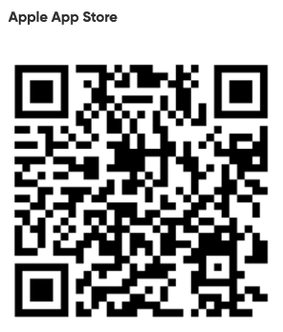 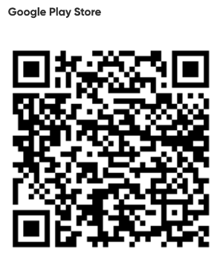
2. 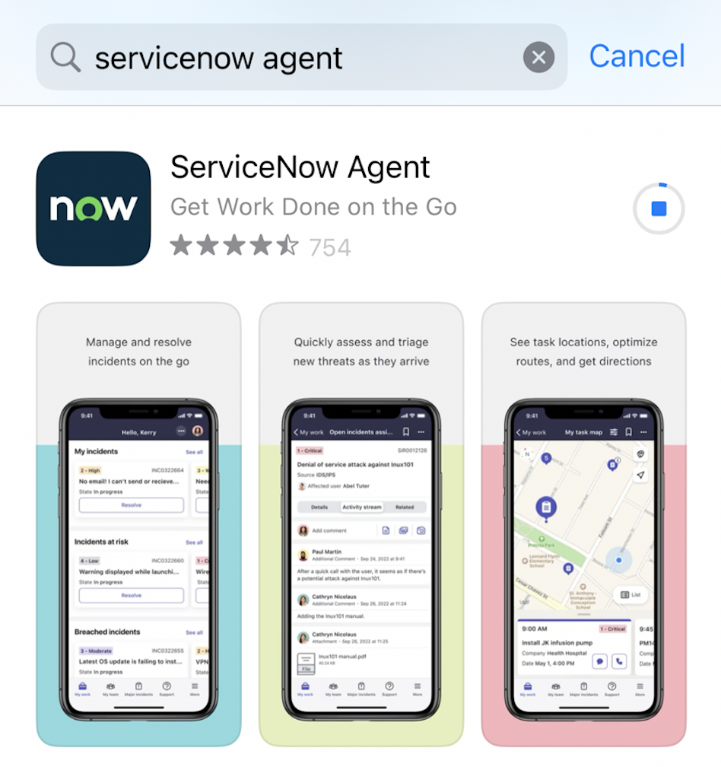Tap ‘**GET’** in the Apple App Store or ‘**Install’** in the Google Play Store.  
     
   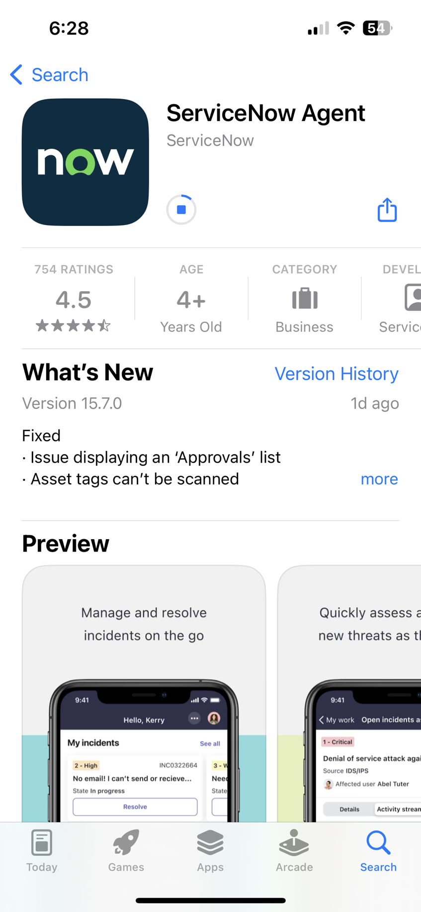
3. Open the installed ServiceNow Agent app. If a notice requesting access to send notifications pops up, tap **Allow**.  
     
   In the instance address field, type in the instance address (URL).   
   [1] Alternatively, create a QR code by copying and pasting the instance's URL into this [QR Code Generator page](https://www.qr-code-generator.com/), which will automatically populate the field for you.  
     
   [2]. Tap the QR code icon next to the instance address URL in the Mobile Agent app, and scan the your generated QR code to populate the instance URL within the app.

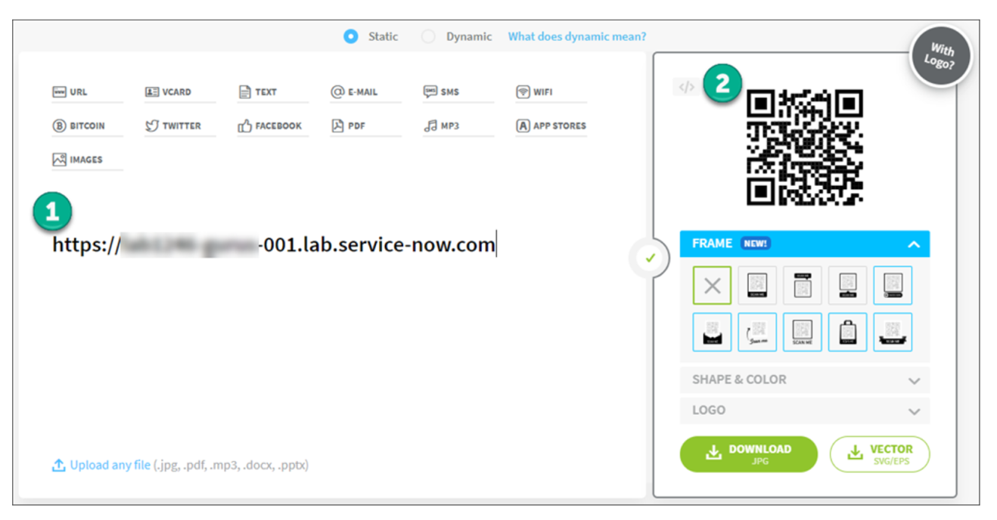  
  
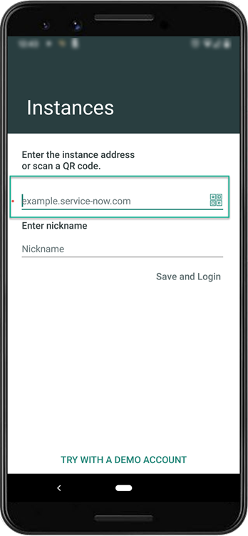 

**Note**: The instance configuration screen may appear different than the example depending on if you are using an Android or iOS device. However, the steps are the same.

1. If a notice requesting access to your device’s camera, tap **Allow**.
2. Tap ‘**Save and Login’**
3. Log in by entering the provided username and password and tap **Login**.

Your credentials:

* 1. Username: admin
  2. **Password:** lab1583-241#K23

1. Upon logging in, you should see the following on your mobile screen:  
     
     
   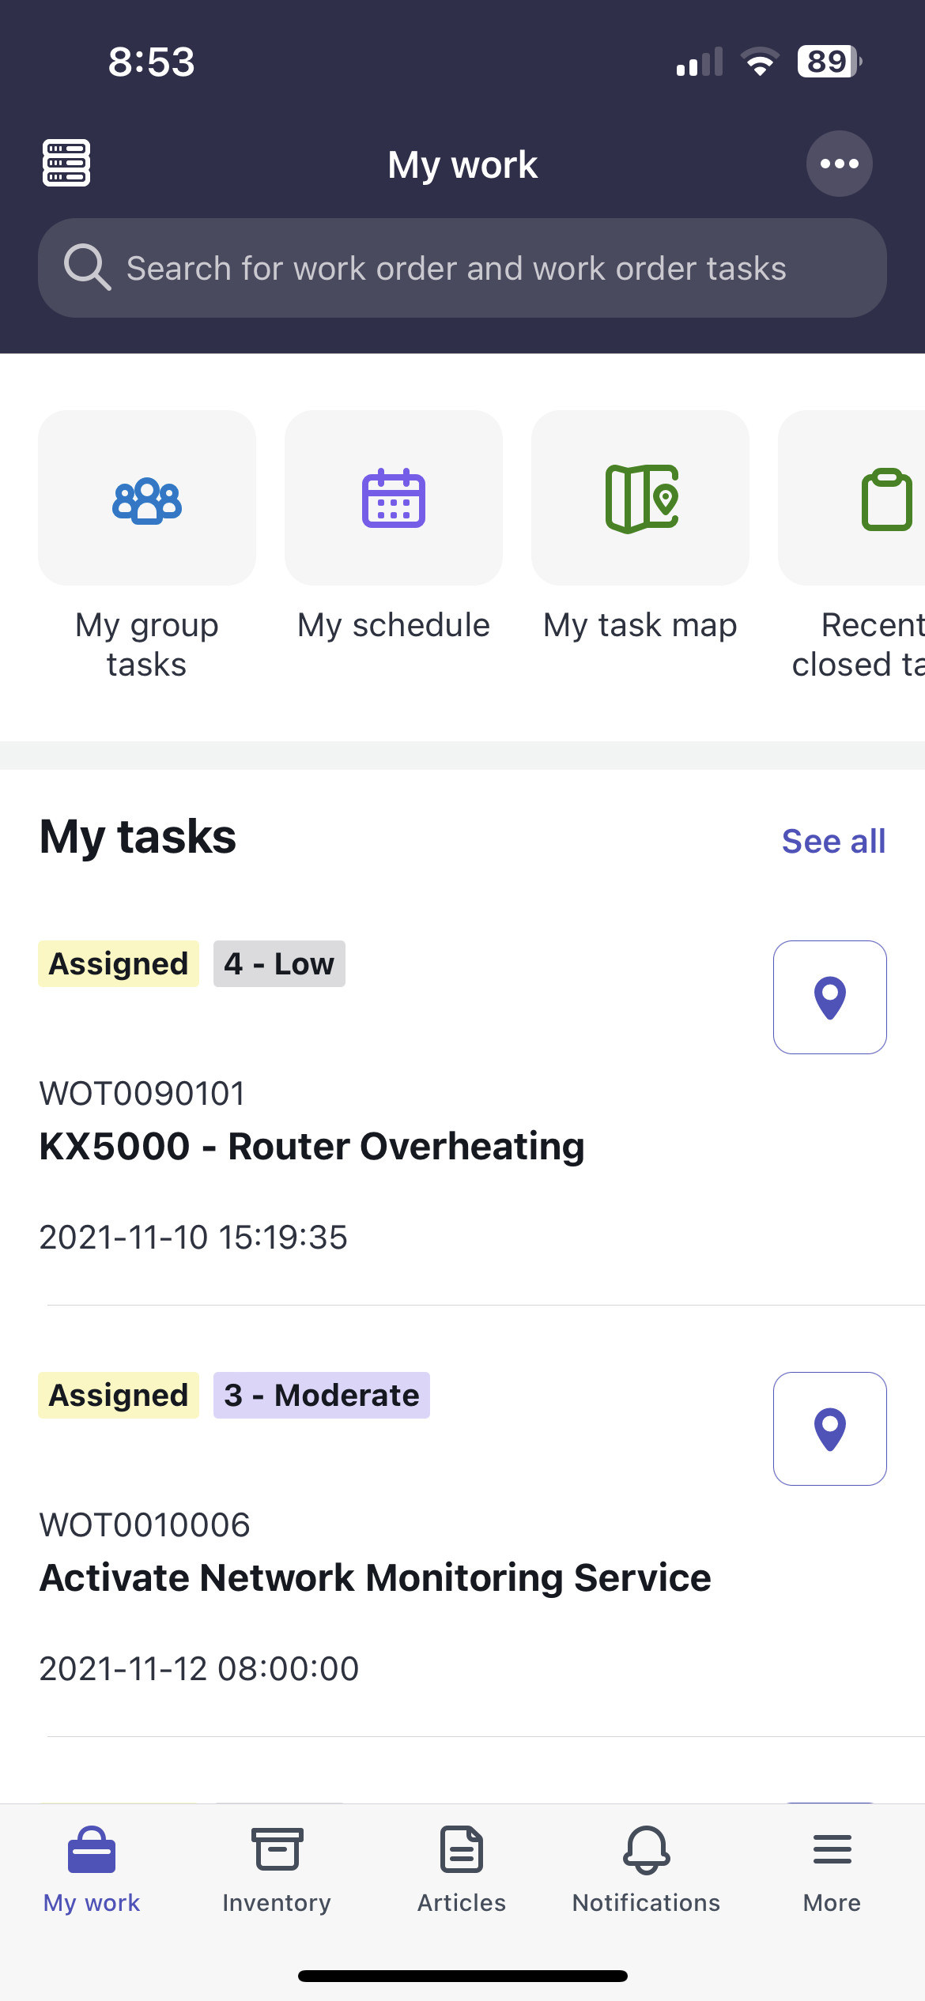

Section 1 Customize the ‘My Task’ List Screen Card

Section 1.1 Open Mobile APP Builder

1. Under your ‘**All**’ tab navigate to > **System Mobile > Mobile App Builder**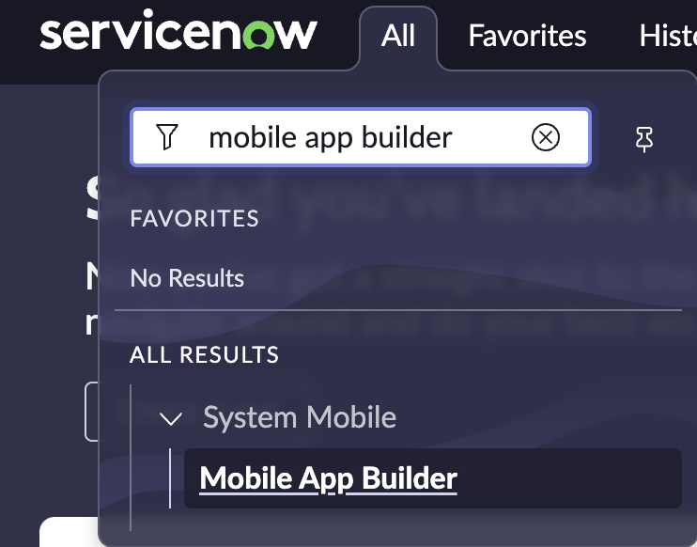
2. Click on **Mobile App Builder**
   * + - 1. This will open Mobile App Builder a new browser tab
3. **Close** the pop-up onboarding module  
     
   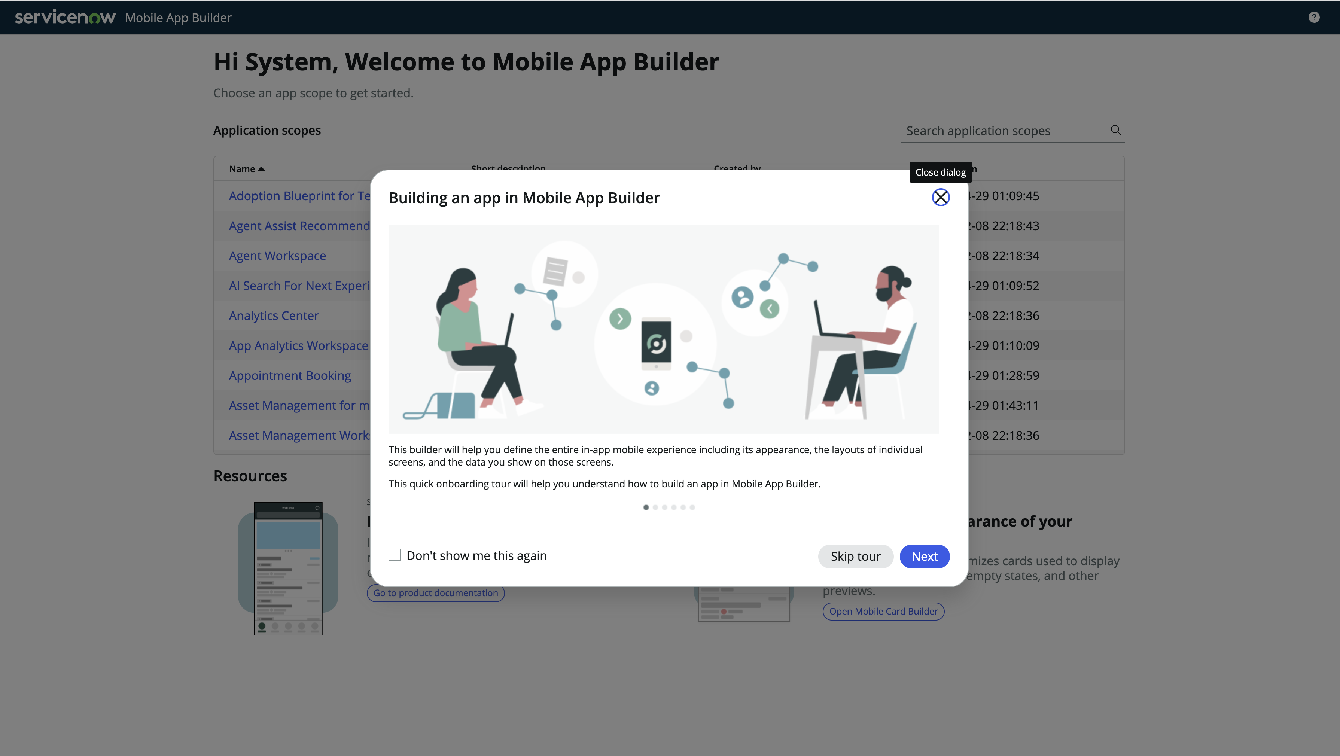

Section 1.2 Open up field service mobile scope

1. In the search bar, search and open the ‘**Field Service Mobile’** application scope  
     
     
   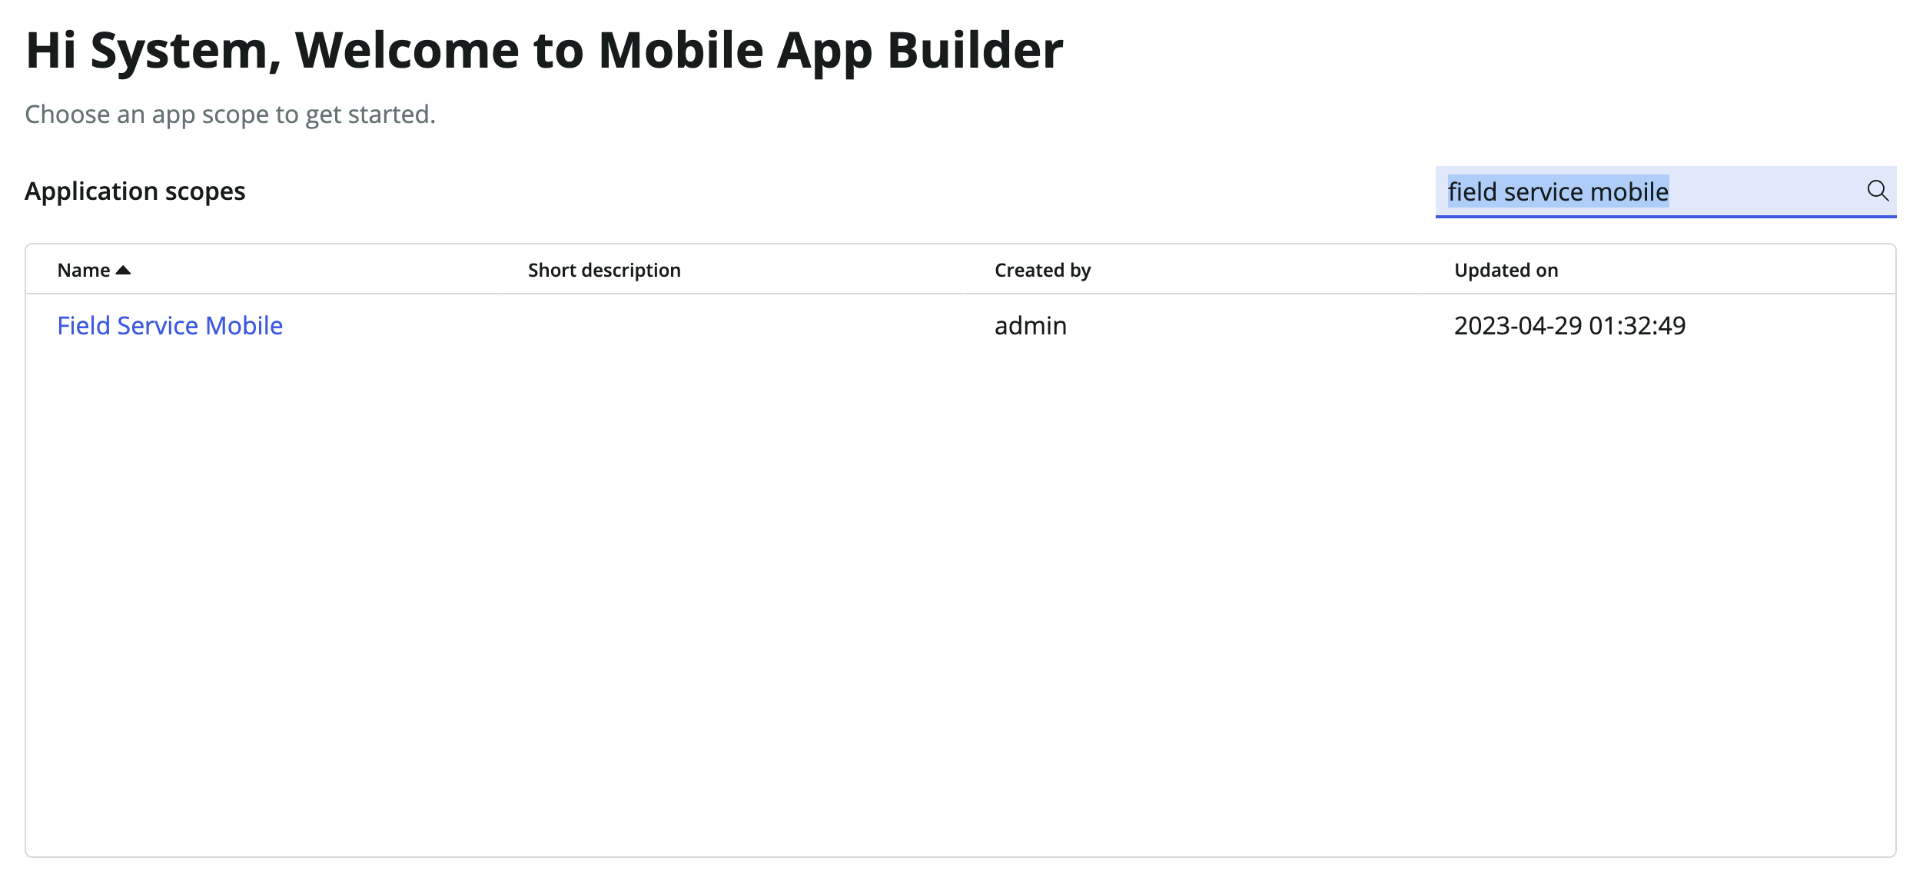
   * + - 1. This will open **the Field Service Mobile** application scope and take you to the record category screen

Section 1.3 Open the ‘My work’ launcher screen

1. On the **screens category**, search and open the ‘**My work’** launcher screen  
     
   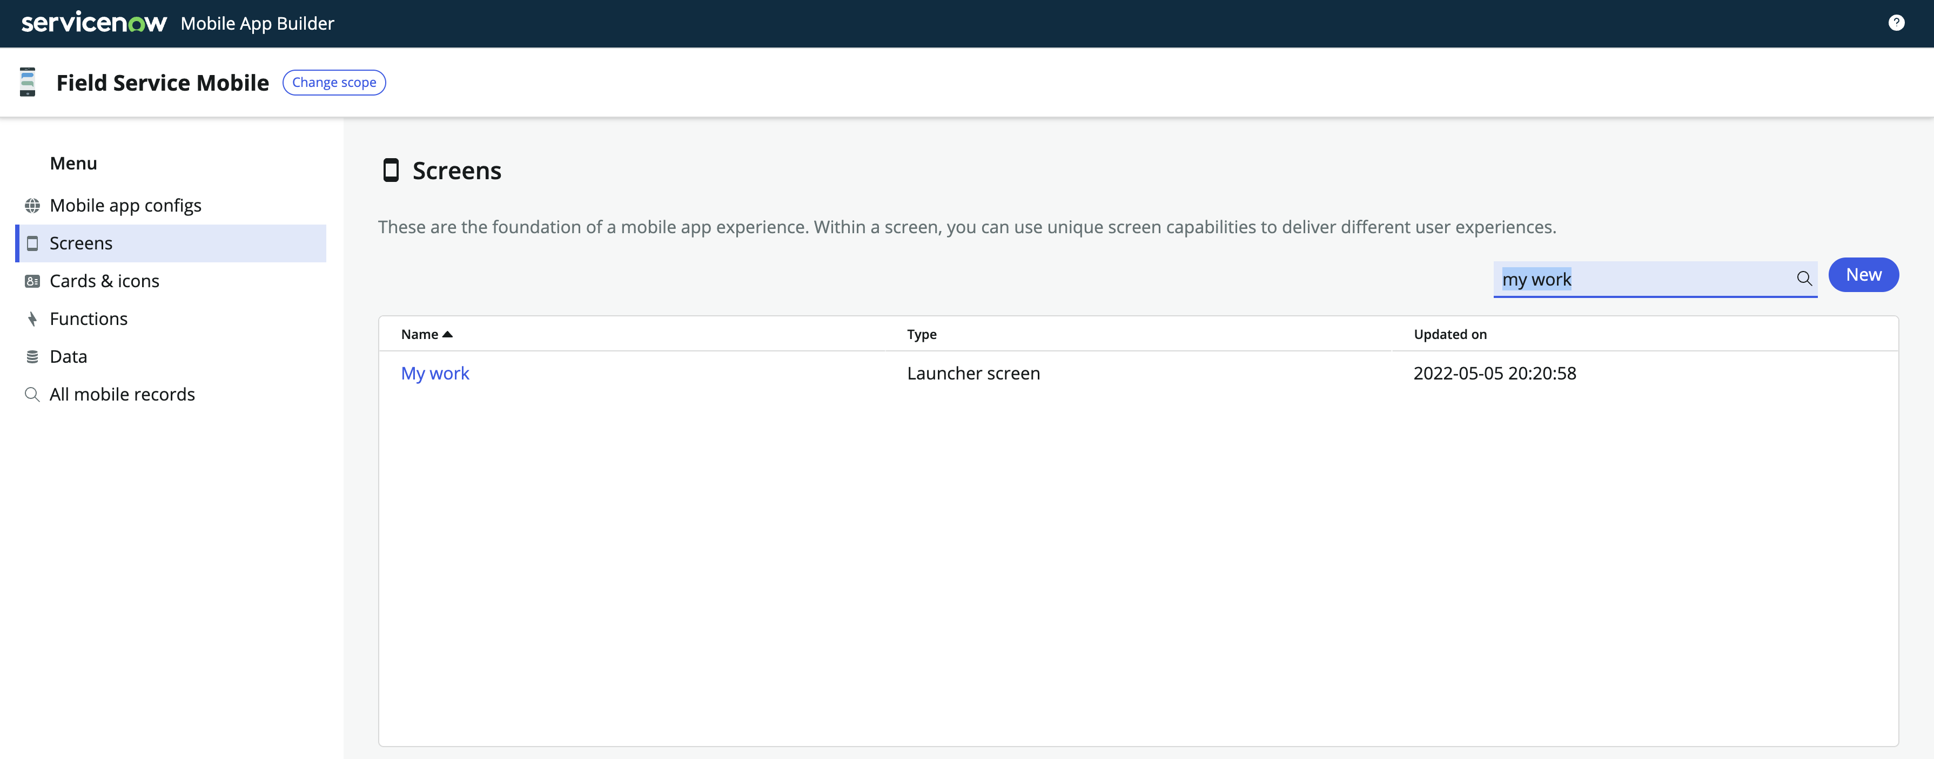

This will open the **My work** launcher screen take you to the record editing screen

1. Close the navigate banner  
     
     
   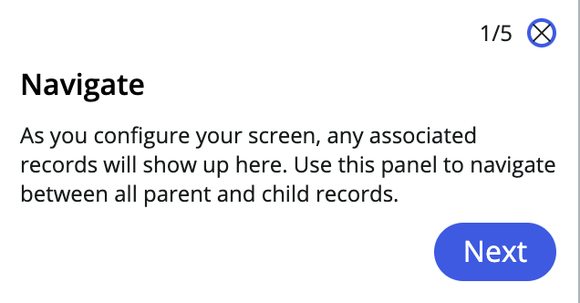
2. Close the yellow notification banner  
     
   

This banner is displayed to inform you that the launcher screen configuration uses records that you do not have permissions to edit. It does not restrict your ability edit other records in the configuration, it is informational only.

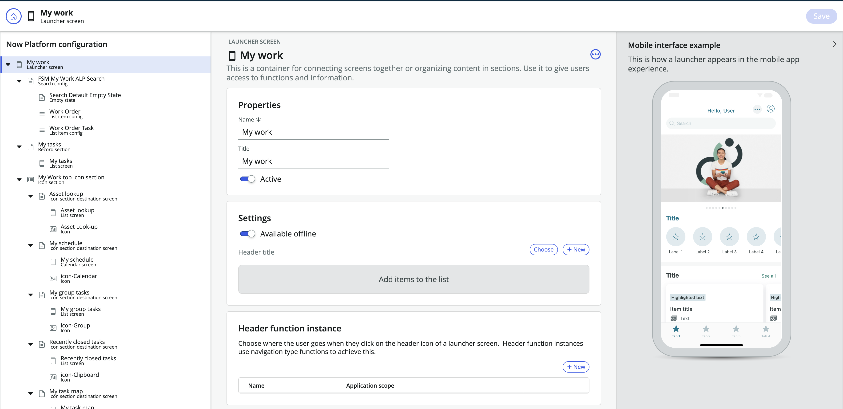

At this point you should have a clean interface to start working within your ‘My Work’ launcher screen

Section 1.4 Modify your ‘My Task’ list screen card

1. On your left hand ‘**Now Platform configuration’ tree**, navigate to [‘My tasks’ record section] > [‘**My Tasks’ list screen**]

This will open the My tasks list screen record config panel and auto focus the record in the left-hand configuration tree

You can also use your keyboard shortcuts to Open Find (cmd+F on Mac) or (ctrl+F on Windows) to quickly find your record on the configuration tree

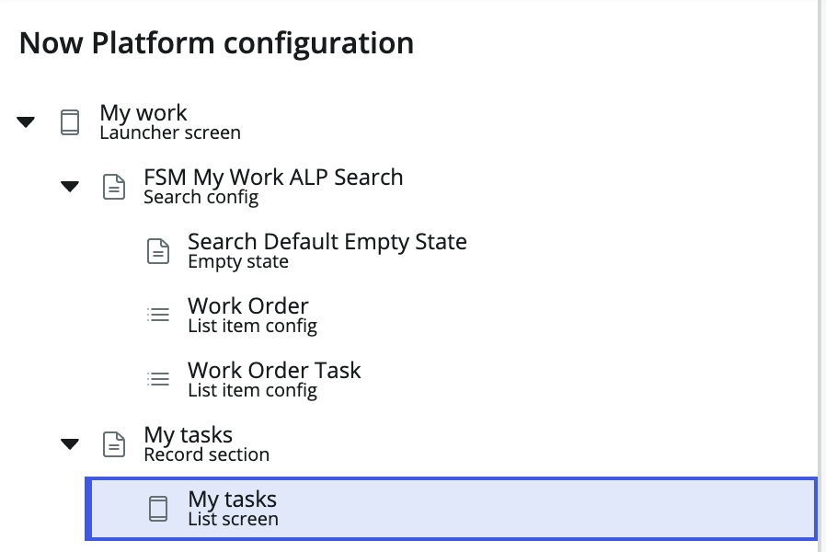

1. In the blue notification banner at the top of your configuration panel, click on ‘**open record’**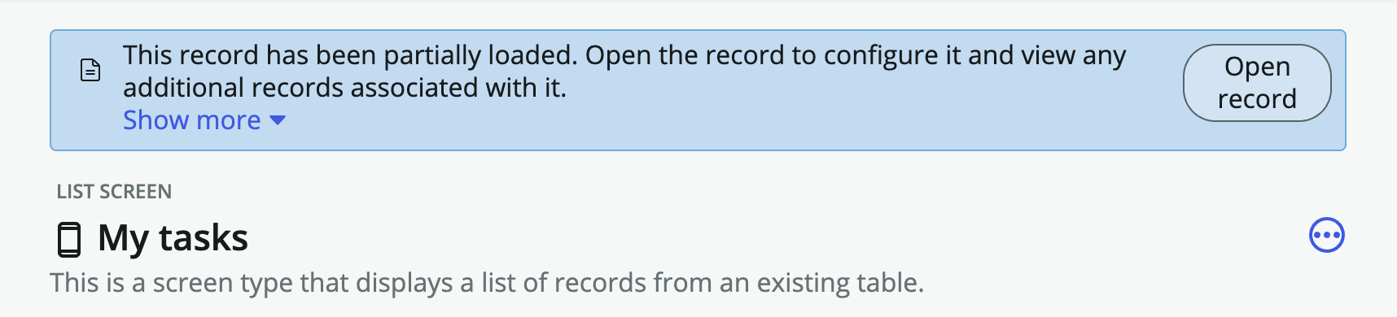

This banner is displayed to inform you that the record has only been partially loaded to improve performance. Opening the record will allow you to configure and view any additional records associated

1. Close the yellow notification banner  
     
   
2. On the left hand configuration tree, navigate to [‘My Tasks List item config’] > [‘**Work Order Task Main Card**]  
     
   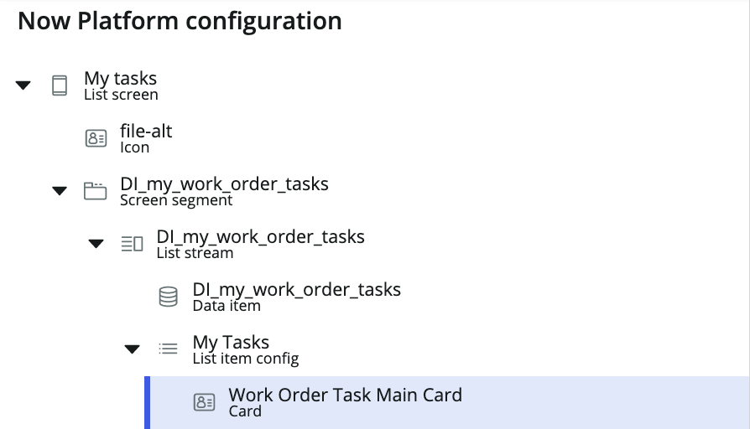
3. On the ‘Work Order Task Main Card’ configuration panel, click on ‘Open in Mobile Card Builder’  
     
   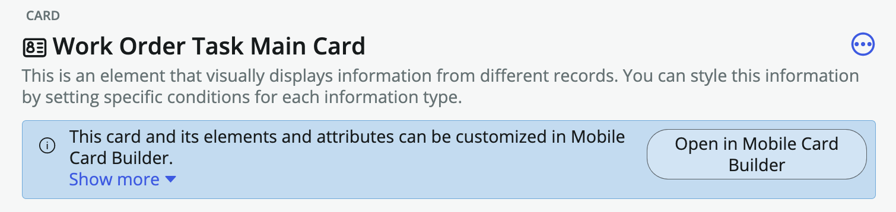  
   * + - 1. This will open up a new browser tab and take you to the card record for you to define the values within your card template
4. In the top left of mobile card builder, navigate to **menu > change template**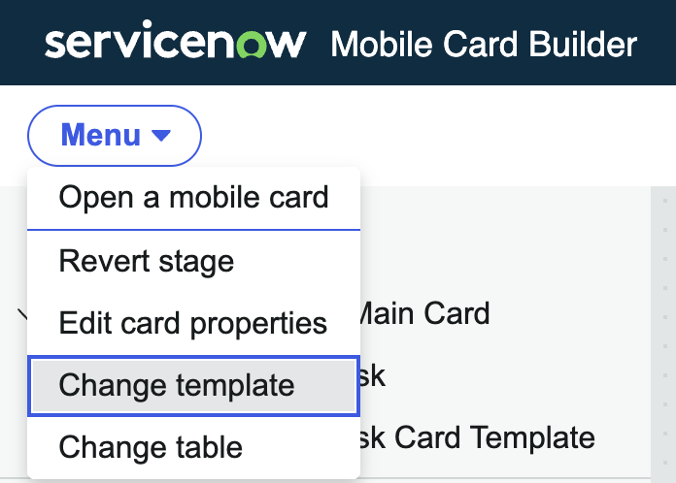

**Note**: You can change your card template depending on how you want to visualize the fields and buttons on your card

1. In the search bar, search and open ‘**Template 01’**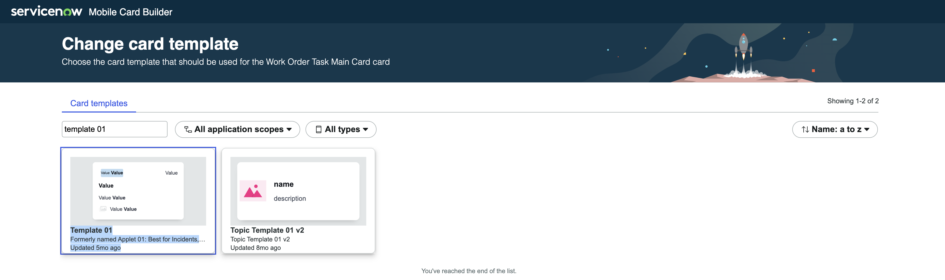

There are many out-of-the-box templates that you can pick from, template 01 is your standard template that is best used to visualize incidents, tasks, and related

1. At the bottom right, click ‘use this card template’   
     
   
2. Click **‘Dismiss all’** on your gray notification at the top  
     
     
     
   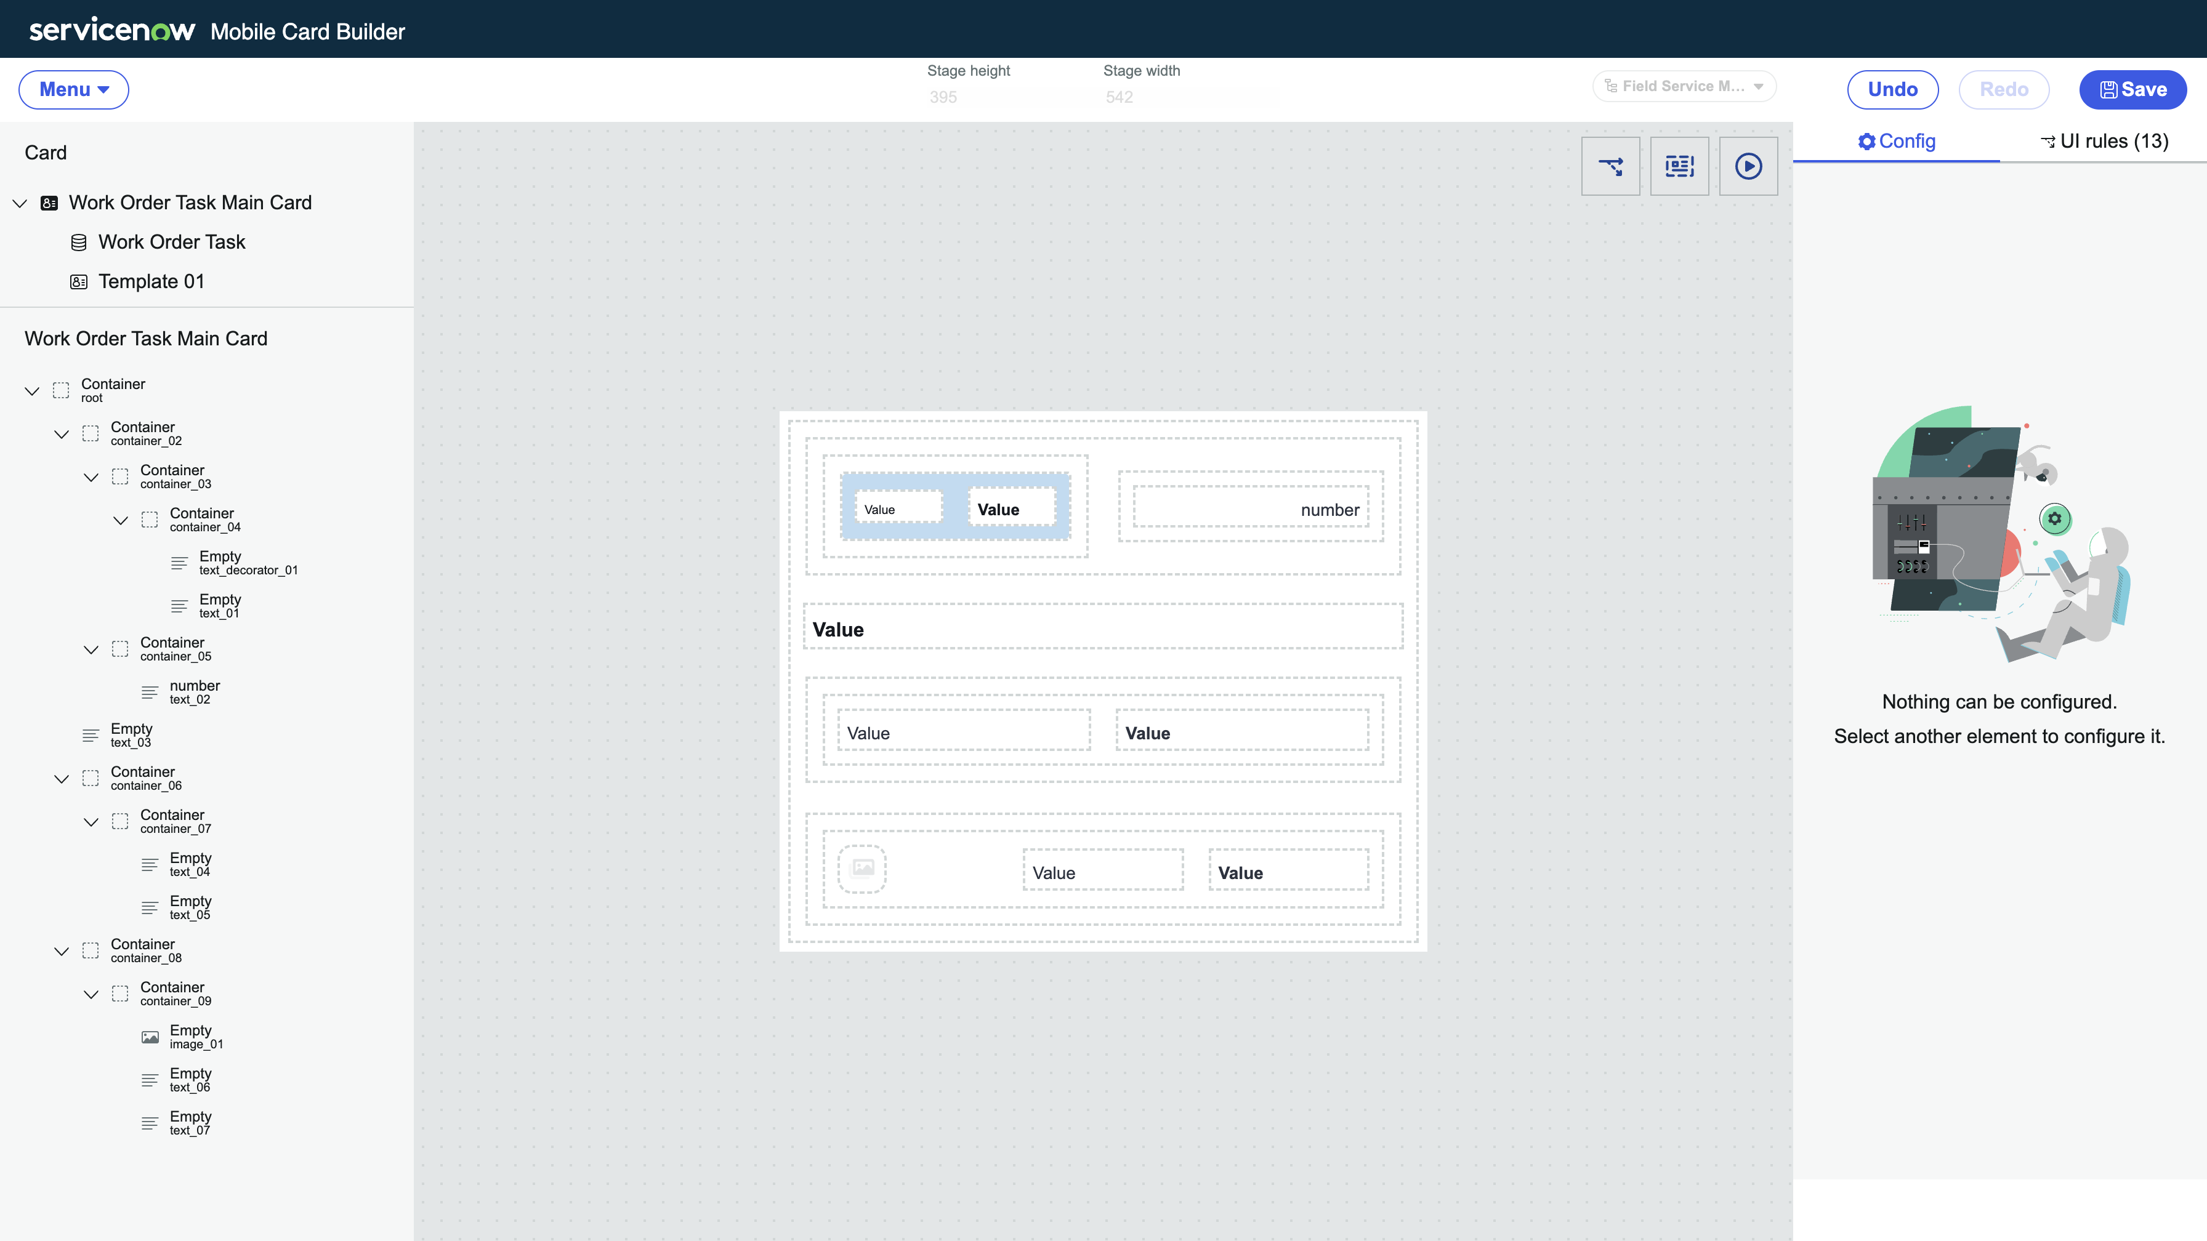

At this point you should have a blank template to start filling in the fields that you want.

Section 1.4 Fill in the fields of your card

1. Select the **highlighted text box** (indicated as **text_decorator_01** on your **left hand nav**) in the screenshot below and fill in the following values:
   1. **Field type**: Field value
   2. **Mapped field**: priority

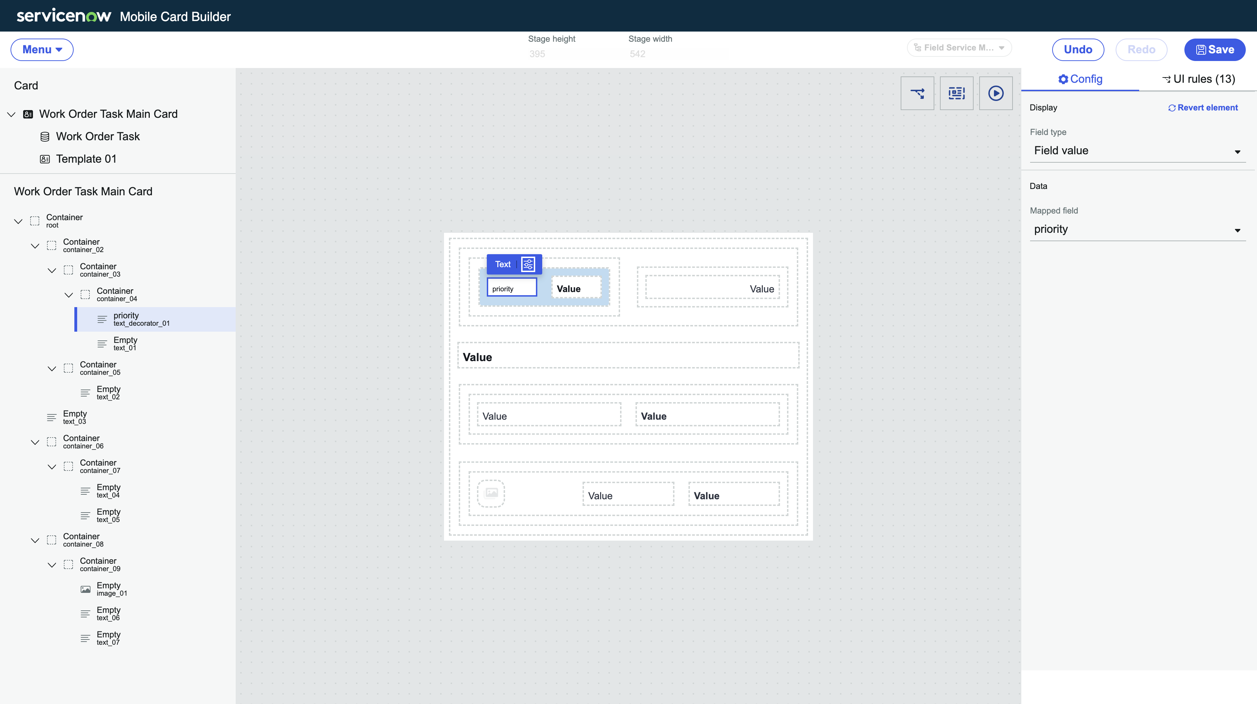

You can ignore and close out the blue banner message related to pre-existing UI rules from the old template



1. Select the **highlighted text box** (indicated as **text_02** on your **left hand nav**) in the screenshot below and fill in the following values:
   1. **Field type**: Field value
   2. **Mapped field**: number

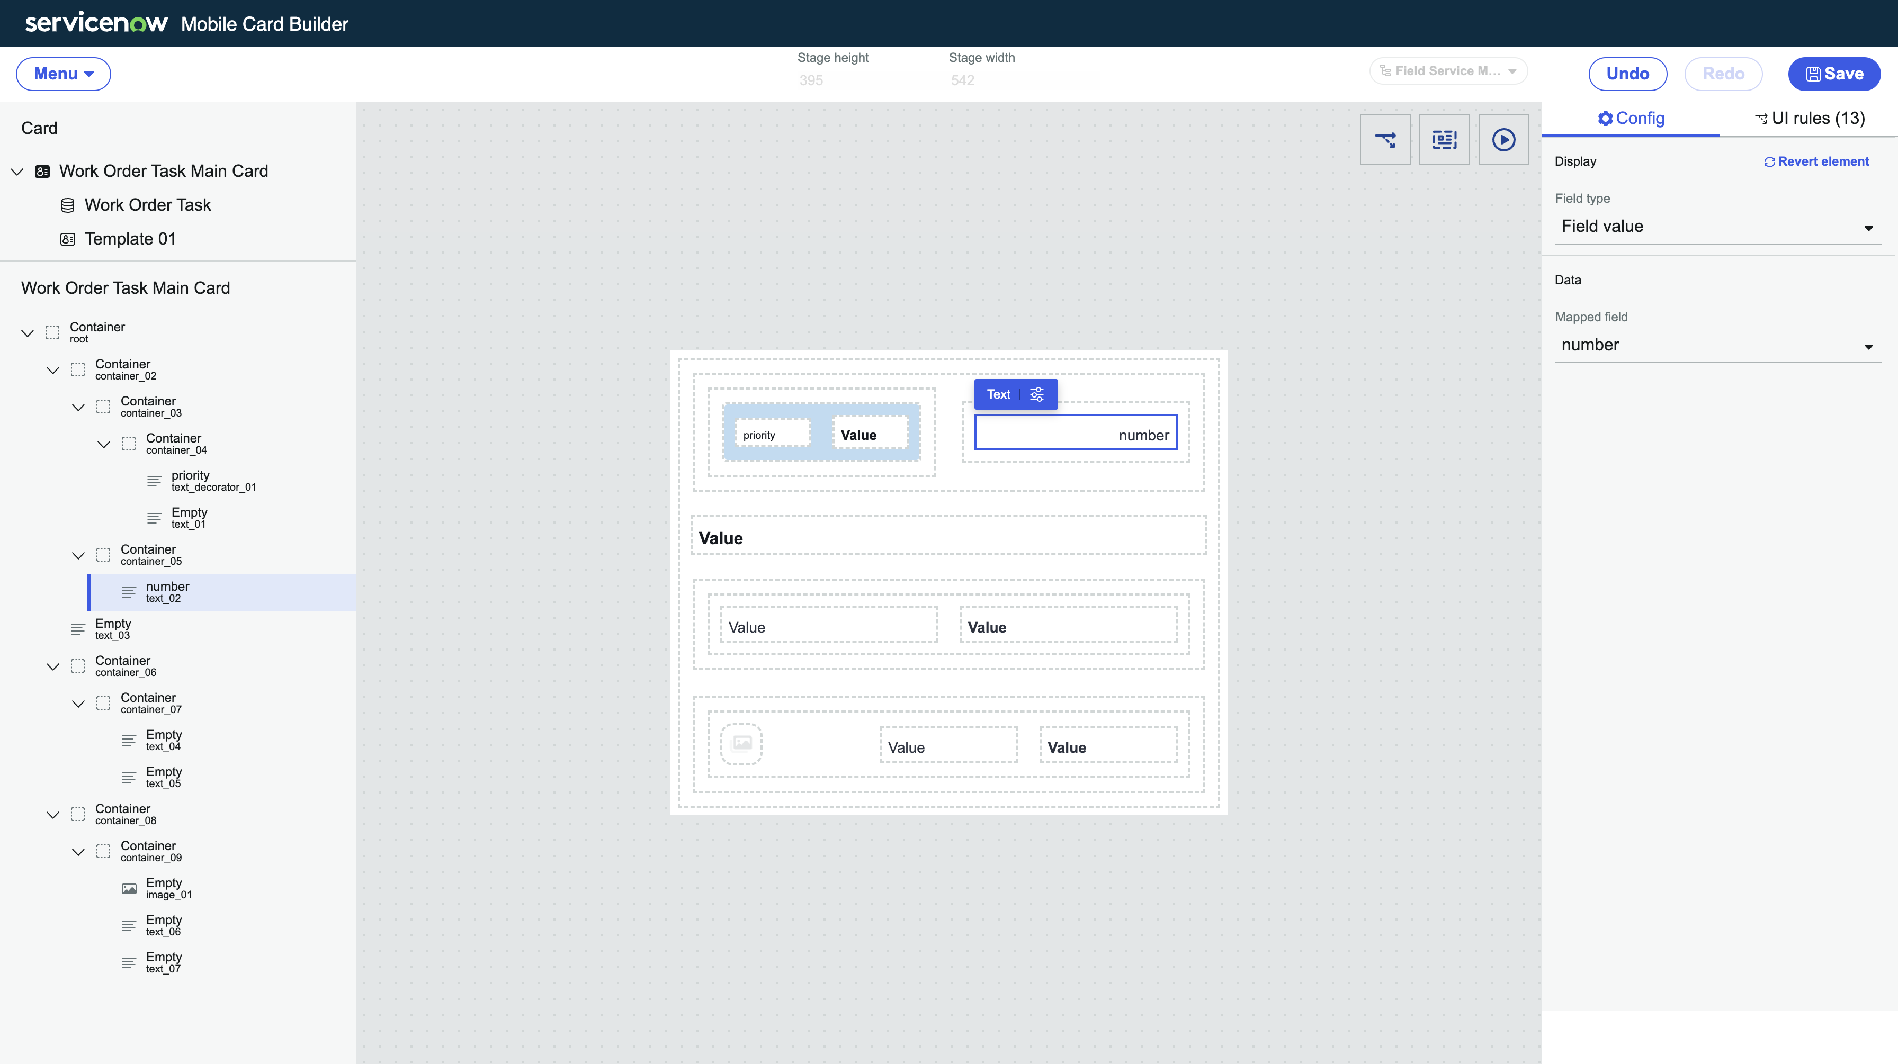

1. Select the **highlighted text box** (indicated as **text_03** on your **left hand nav**) in the screenshot below and fill in the following values:
   1. **Field type**: Field value
   2. **Mapped field**: short_description

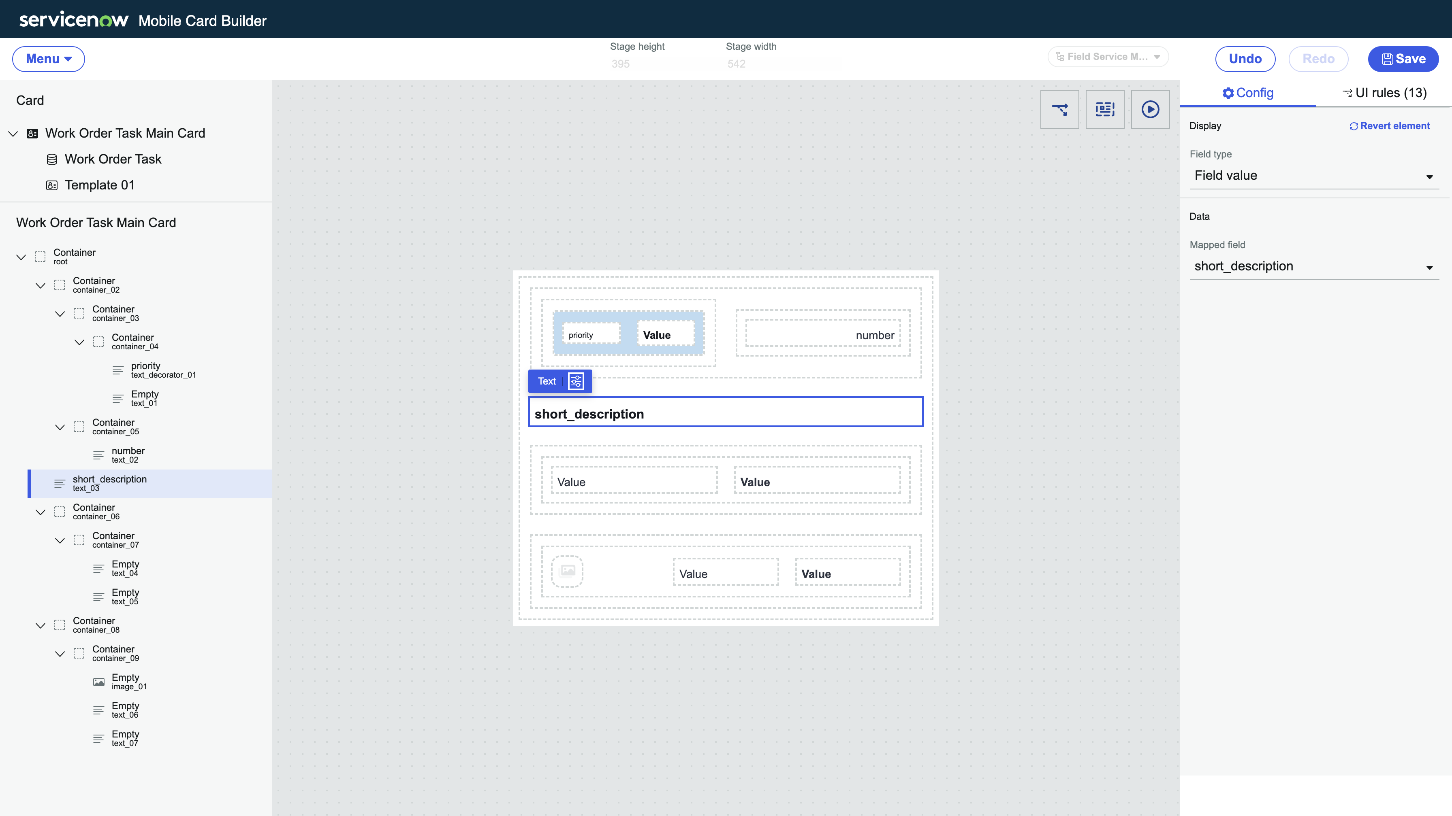

1. Select the **highlighted text box** (indicated as **text_04** on your **left hand nav**) in the screenshot below and fill in the following values:
   1. **Field type**: Field value
   2. **Mapped field**: state

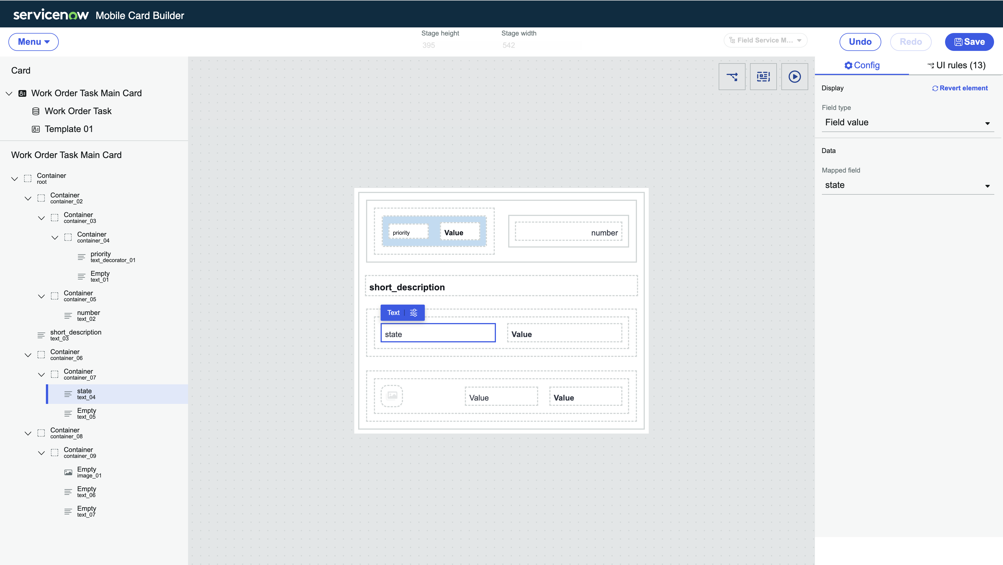

1. Select the **highlighted text box** (indicated as **image_01** on your **left hand nav**) in the screenshot below and fill in the following values:
   1. **Use mapped field**: TRUE
   2. **Mapped field**: opened by > avatar (click on arrow next to field to dot walk)

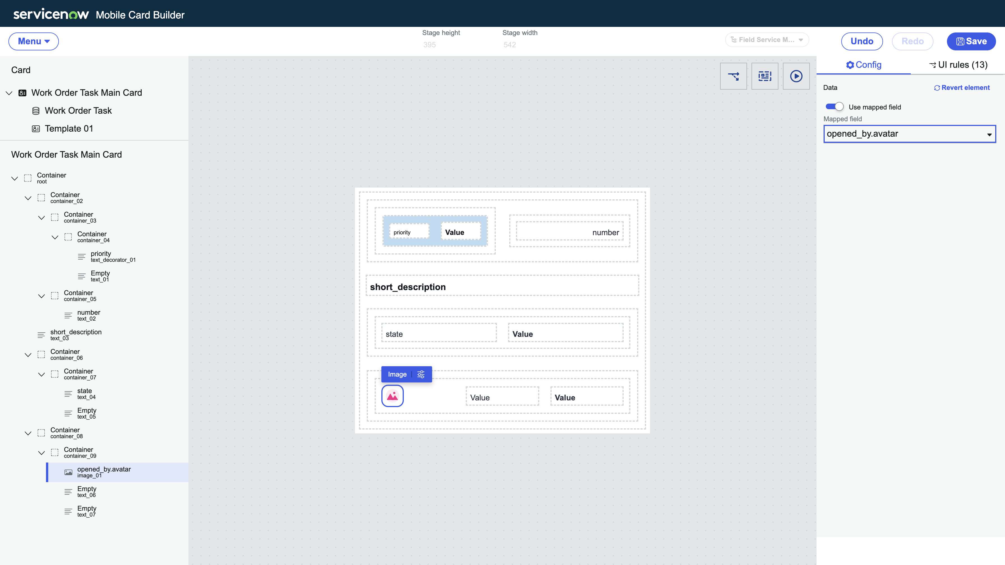

1. Select the **highlighted text box** (indicated as **text_06** on your **left hand nav**) in the screenshot below and fill in the following values:
   1. **Field type**: Field Label**\*\*\***
   2. **Mapped field**: opened_by

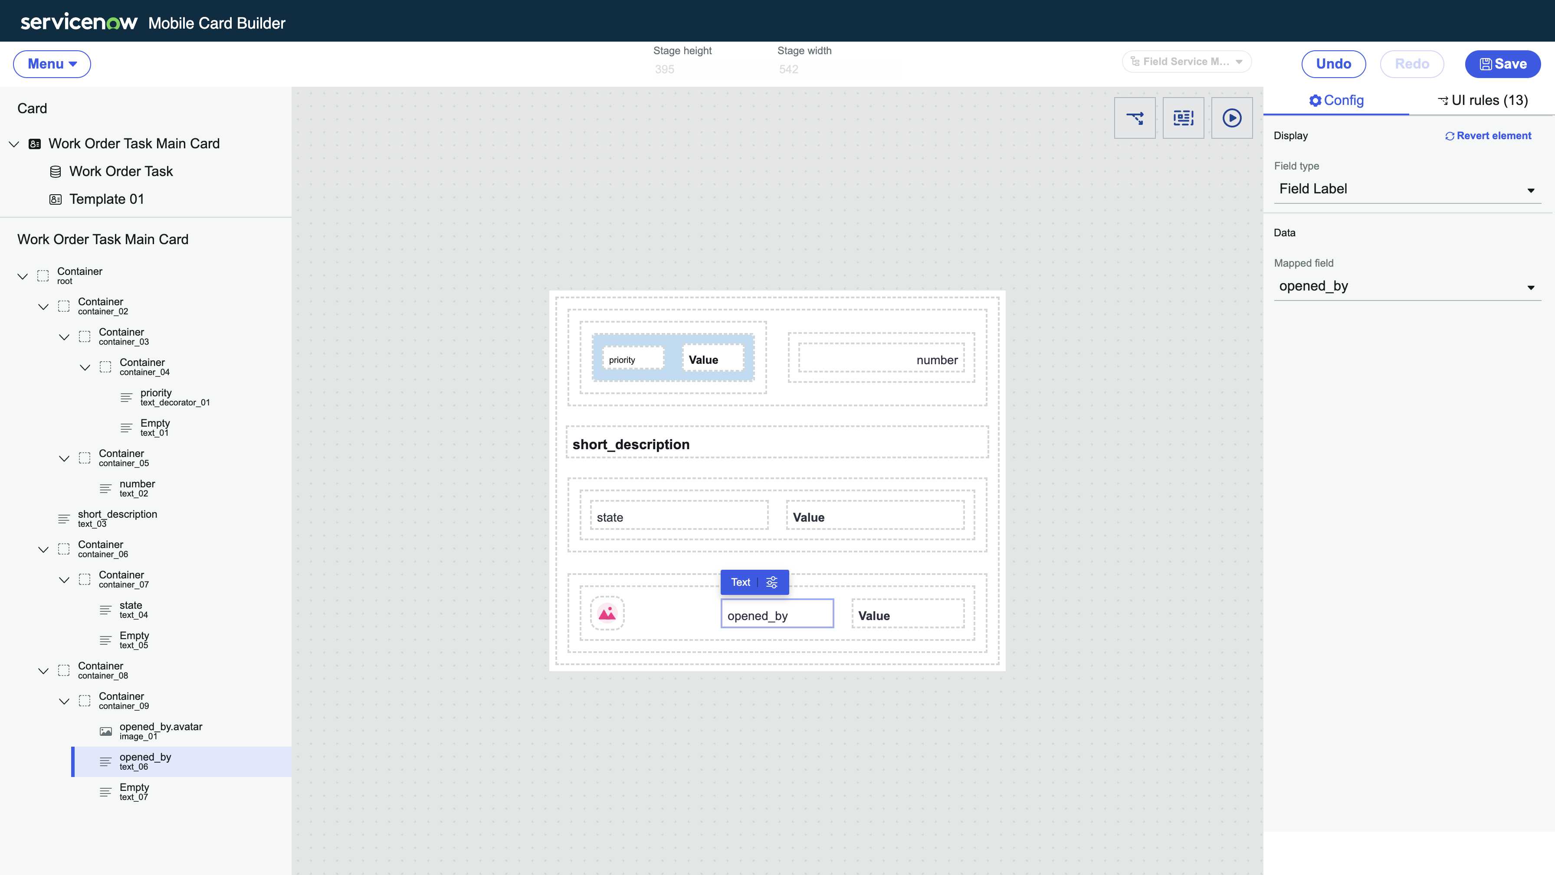

1. Select the **highlighted text box** (indicated as **text_07** on your **left hand nav**) in the screenshot below and fill in the following values:
   1. **Field type**: Field Label**\*\*\***
   2. **Mapped field**: opened_by

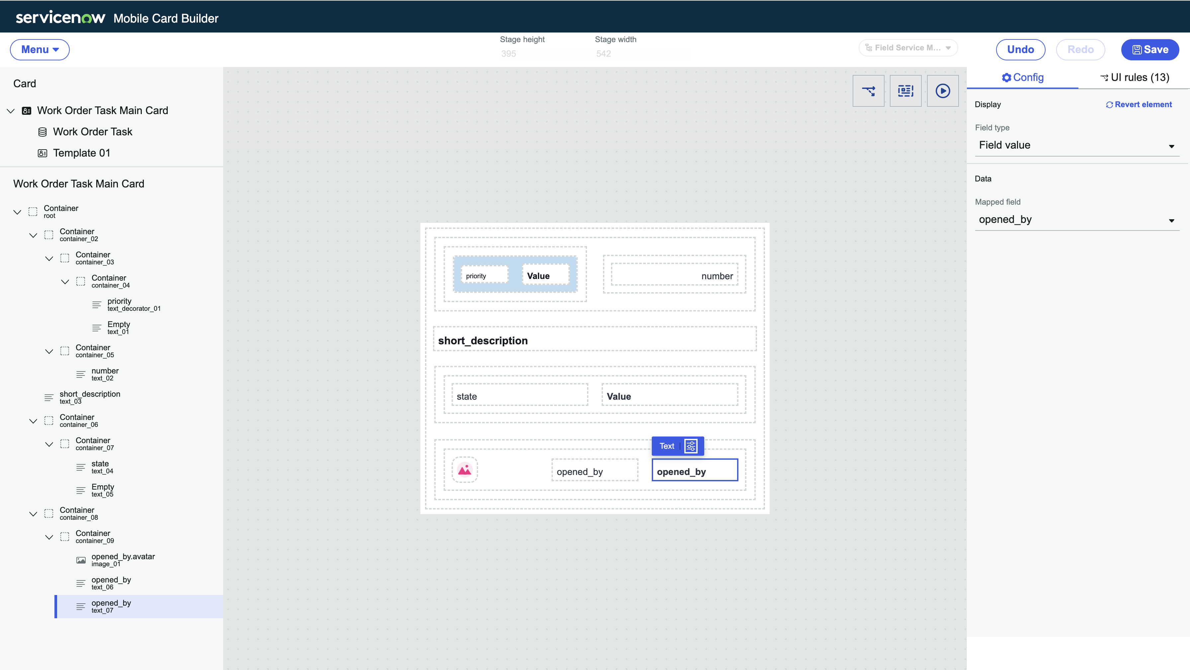

At this point you should have all 8 fields filled into your card

1. Click ‘**save’** at the top right of your mobile card builder

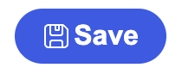

Keep your mobile card builder tab open to prepare for the next section.

1. Open up the ServiceNow Agent app and refresh (swipe your finger from top down) your ‘My Work’ screen launcher tab to update all of your changes.

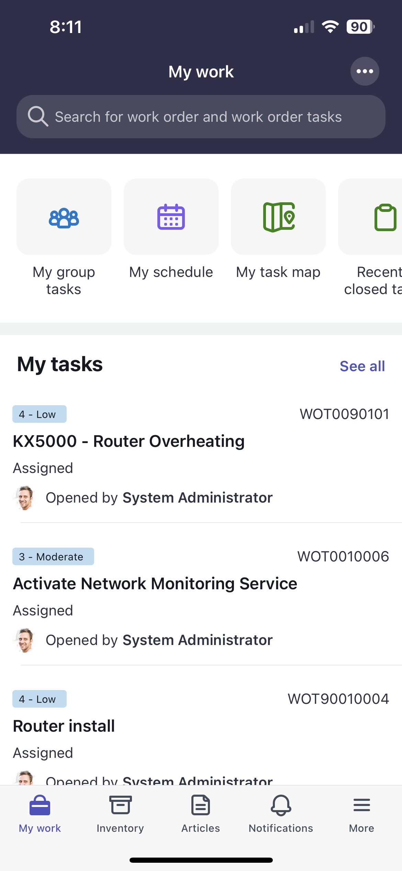

Section 2 Configure a UI rule on your mobile card

Section 2.1 Highlight the ‘number’ field on your card

1. Select the **highlighted text box** (indicated as **text_02** on your **left hand nav**) in the screenshot below and fill in the following values:  
     
   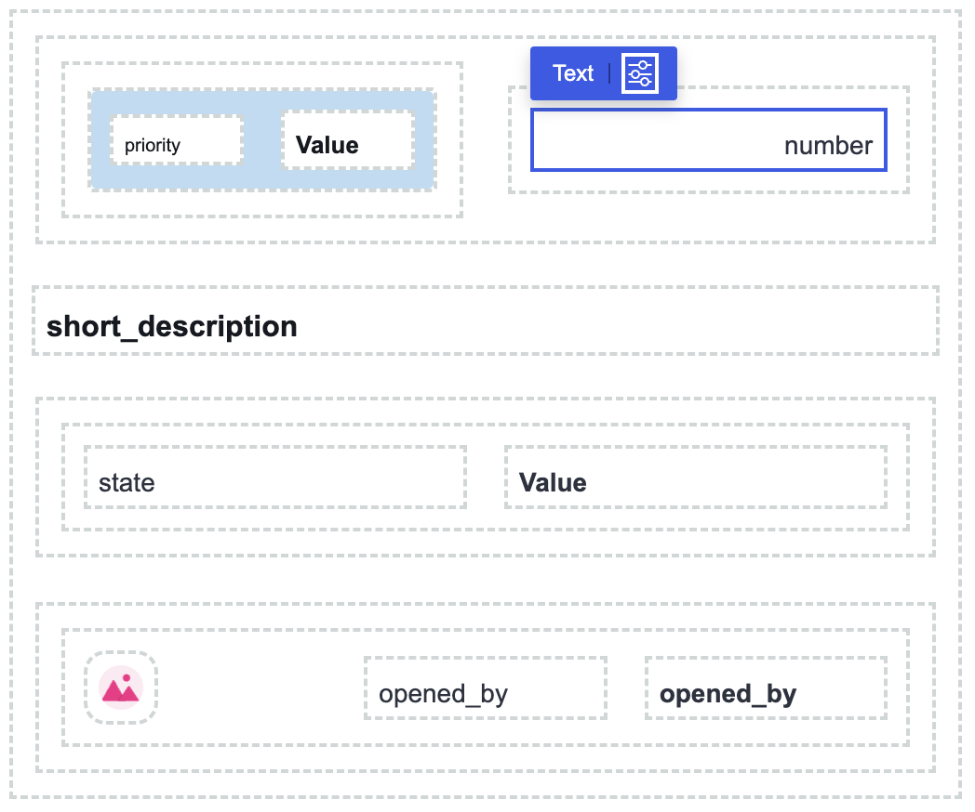

Make sure the number field is clicked and highlighted at all times when applying your mobile UI rule

1. On the right-hand config panel, click on the ‘**UI rules**’ tab  
     
   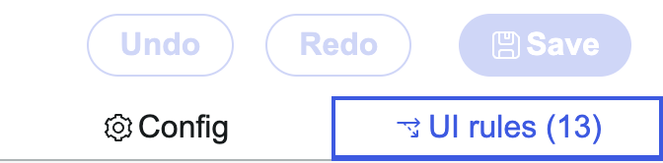
2. Click on **‘+ add a UI rule’**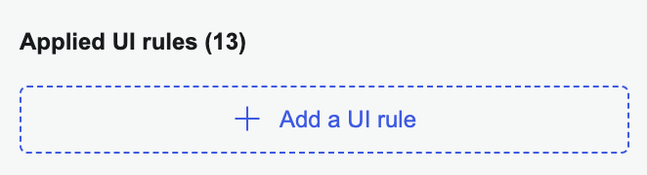

You can ignore the pre-existing UI rules which were created out-of-the-box

1. In the pop-up UI rule window, fill in the following fields:
   1. **Name**: Highlight number when priority is moderate
   2. **Active**: True
   3. **Reverse is false**: False
   4. **Condition**: Priority is ‘3 - Moderate’

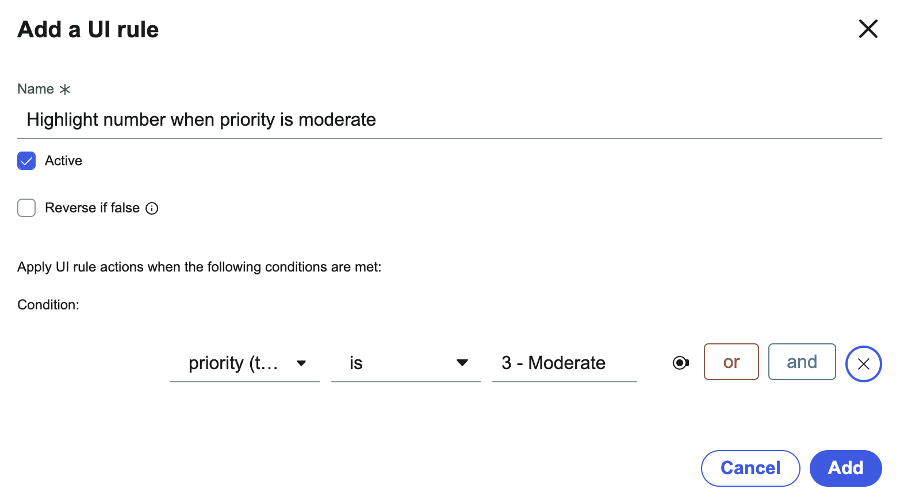

1. Click ‘**Add’** to save your UI rule  
     
   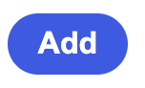
2. Find your UI rule you just created in the list of UI rules, and click on the **split-arrow icon** to add a rule action  
     
   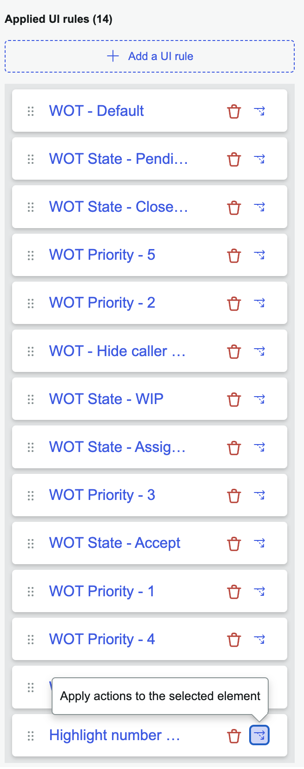

If the icon is grayed out, you need to remember to click and highlight your number field to apply your UI rule action

1. In the pop-up window for UI rule actions, fill in the following fields:
   1. **Change text color (toggle)**: TRUE
   2. **Text color**: #FD9700 (orange)
2. Click ‘**save’** at the top right of your mobile card builder



1. Open up the ServiceNow Agent app and refresh (swipe your finger from top down) your ‘My Work’ screen launcher tab to update all of your changes.  
     
   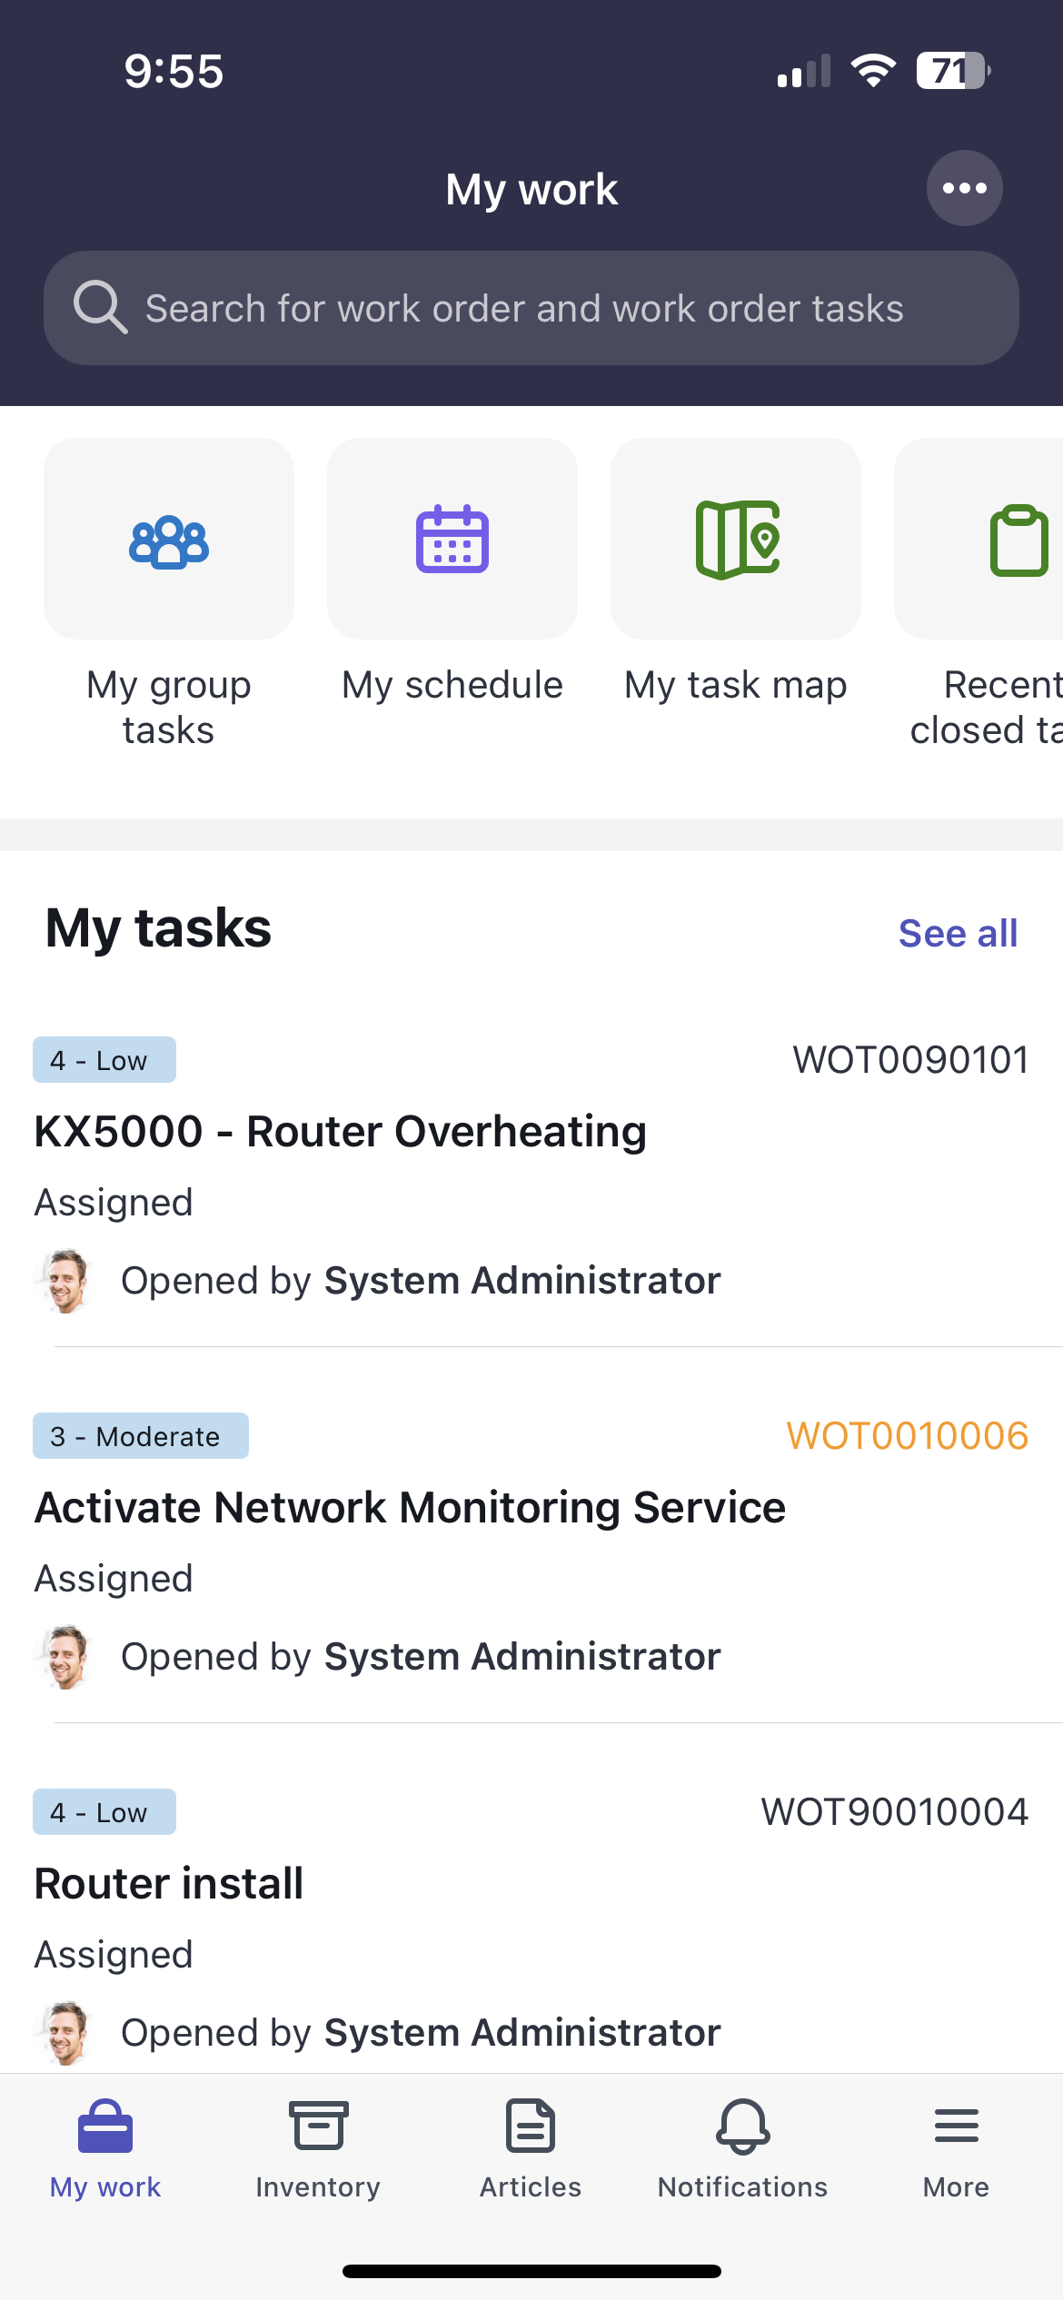

Section 3 Customizing mobile icons

Section 3.1 Changing icons on a navigation bar

1. Go back to your browser tab with **Mobile App Builder** and click on the ‘**home’** icon   
     
     
     
   This should return you to the home screen of your field service mobile application scope  
     
   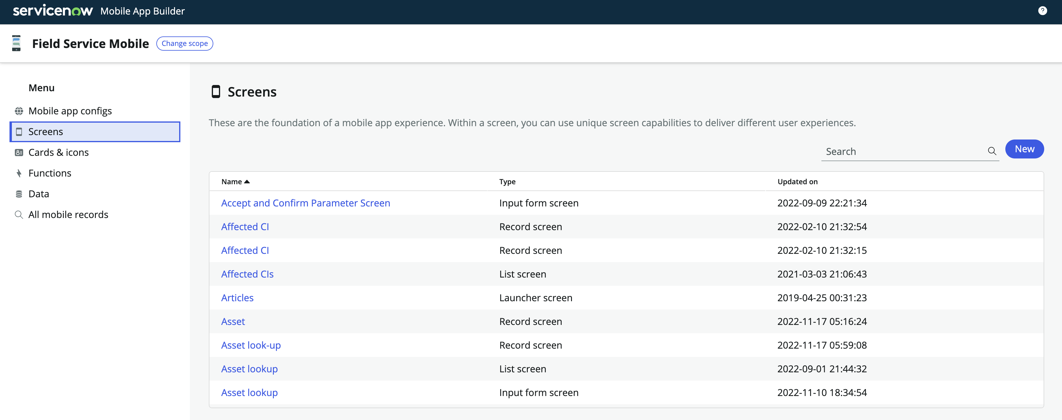
2. On the **cards & icons category**, click ‘**new’** to create a new icon.  
     
   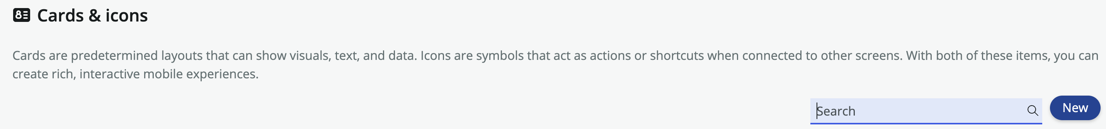
3. Select the ‘**icon’** type and click ‘**continue’**  
     
   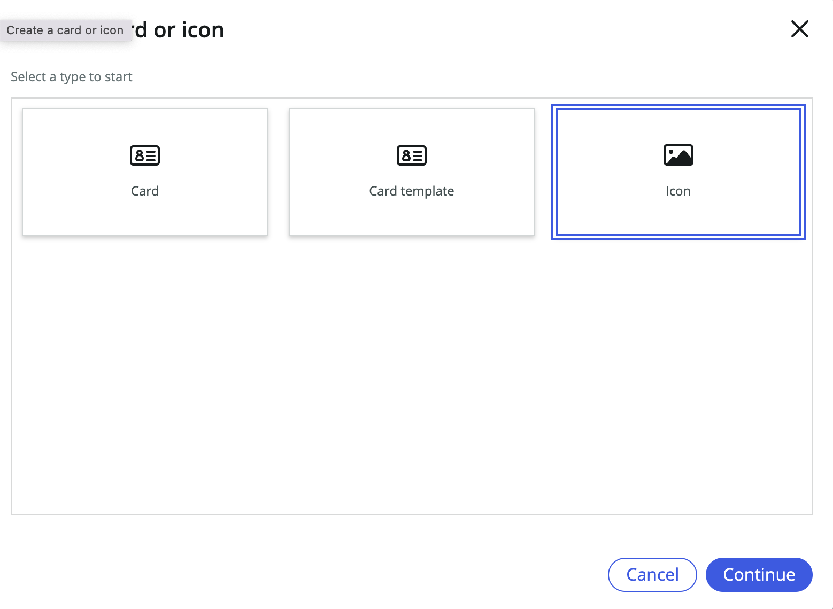
4. Fill in the following fields:

**Properties**

* Name: Home Tab
* Type: Image

**Set Appearance**

1. Style: Name

Value: Home

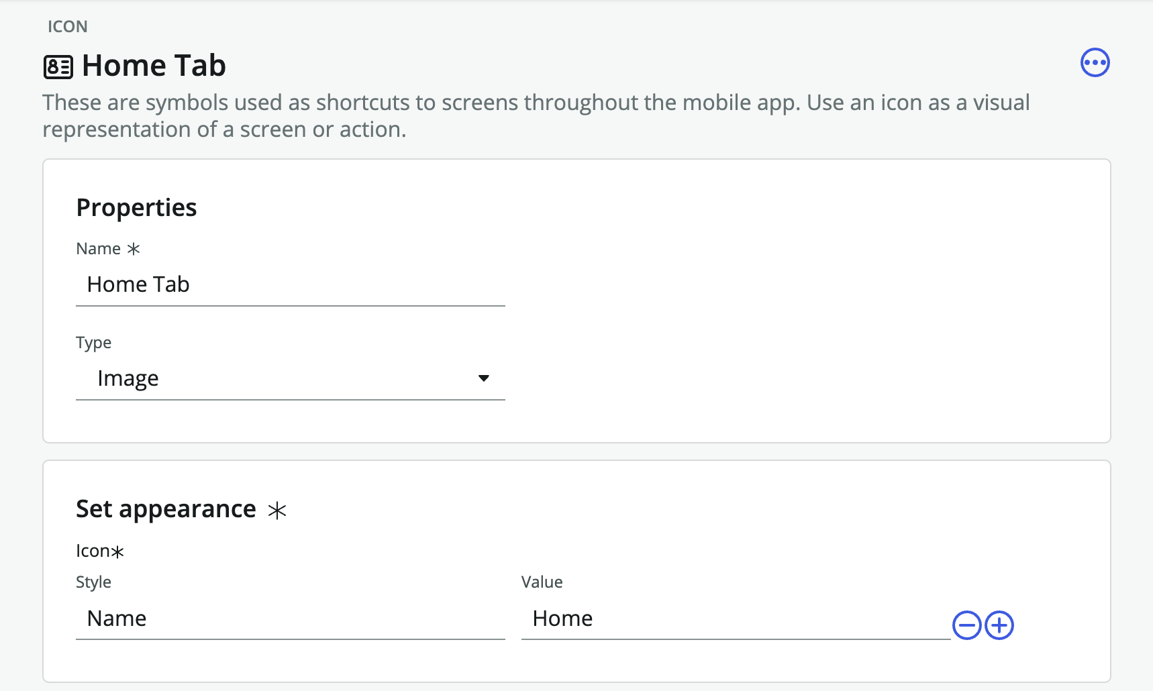

1. Go back to your browser tab with **Mobile App Builder** and click on the ‘**home’** icon   
     
     
   This should return you to the home screen of your field service mobile application scope  
     
   
2. On the **All mobile records category**, search and open the following:
   1. **Record type**: Navigation tab [sys_sg_navigation_tab]
   2. **Search**: My Work

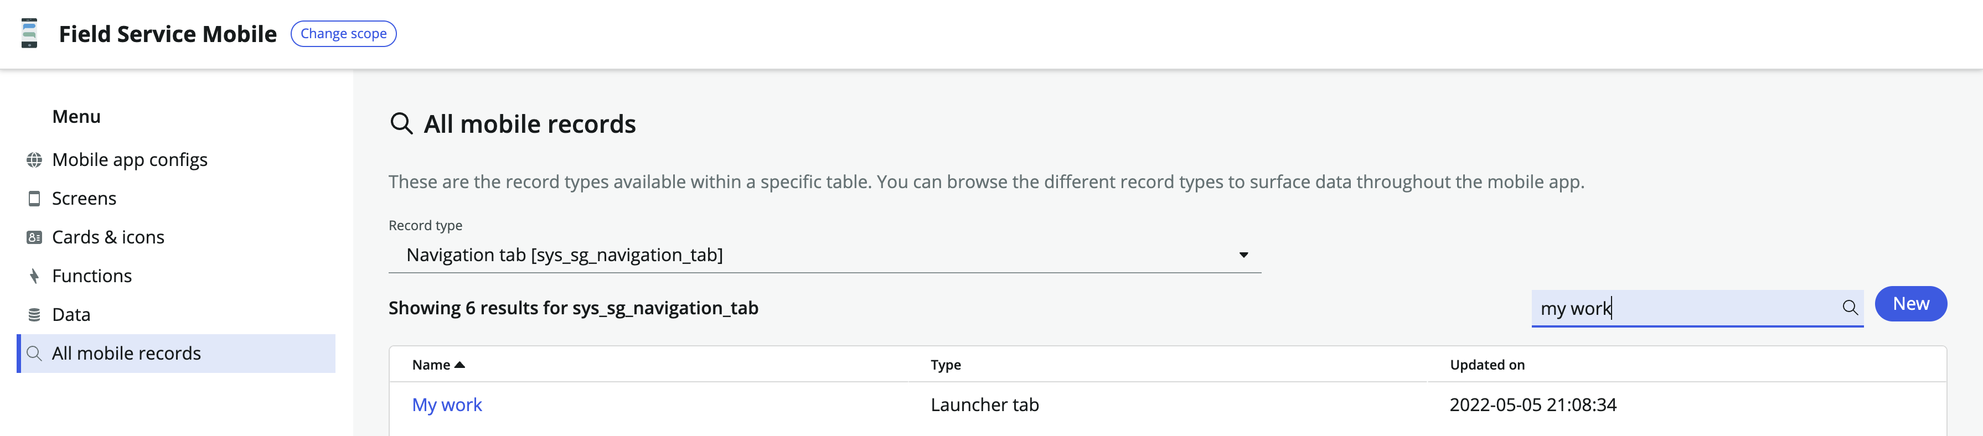

1. Under the icon section, click on the ‘**-**‘ icon to remove the existing icon  
     
   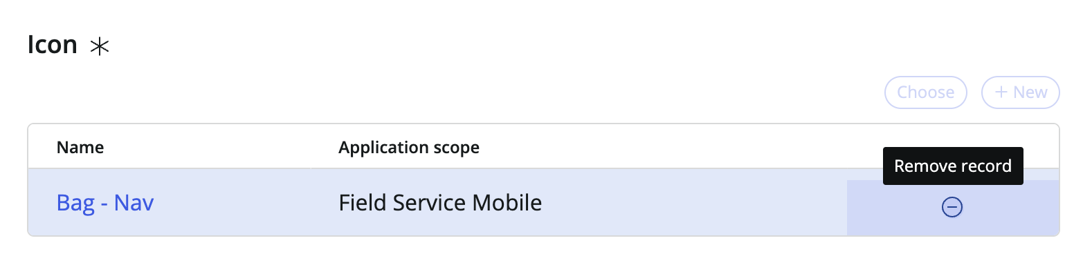
2. Click on ‘**choose’** under the icon table

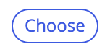

1. Search for your icon ‘**Home Tab’** and click ‘**apply’**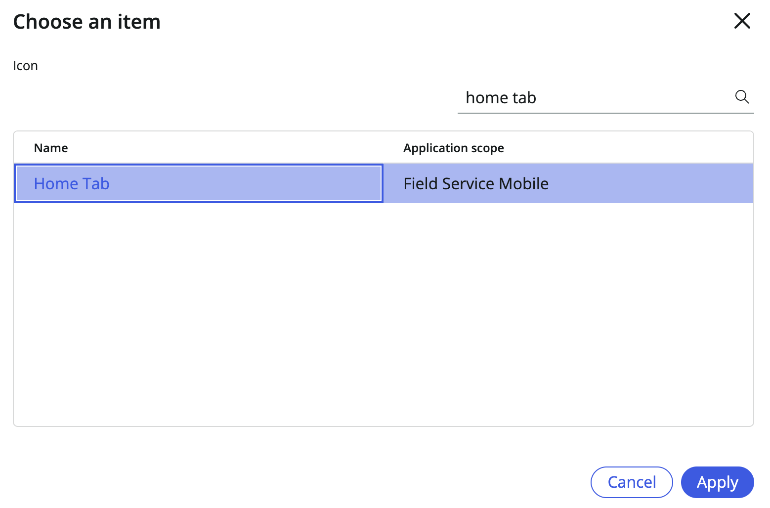
2. On the top right of your ‘My Work’ launcher tab, click ‘**save’**
3. Open up the ServiceNow Agent app and refresh (swipe your finger from top down) your ‘My Work’ screen launcher tab to update all of your changes.

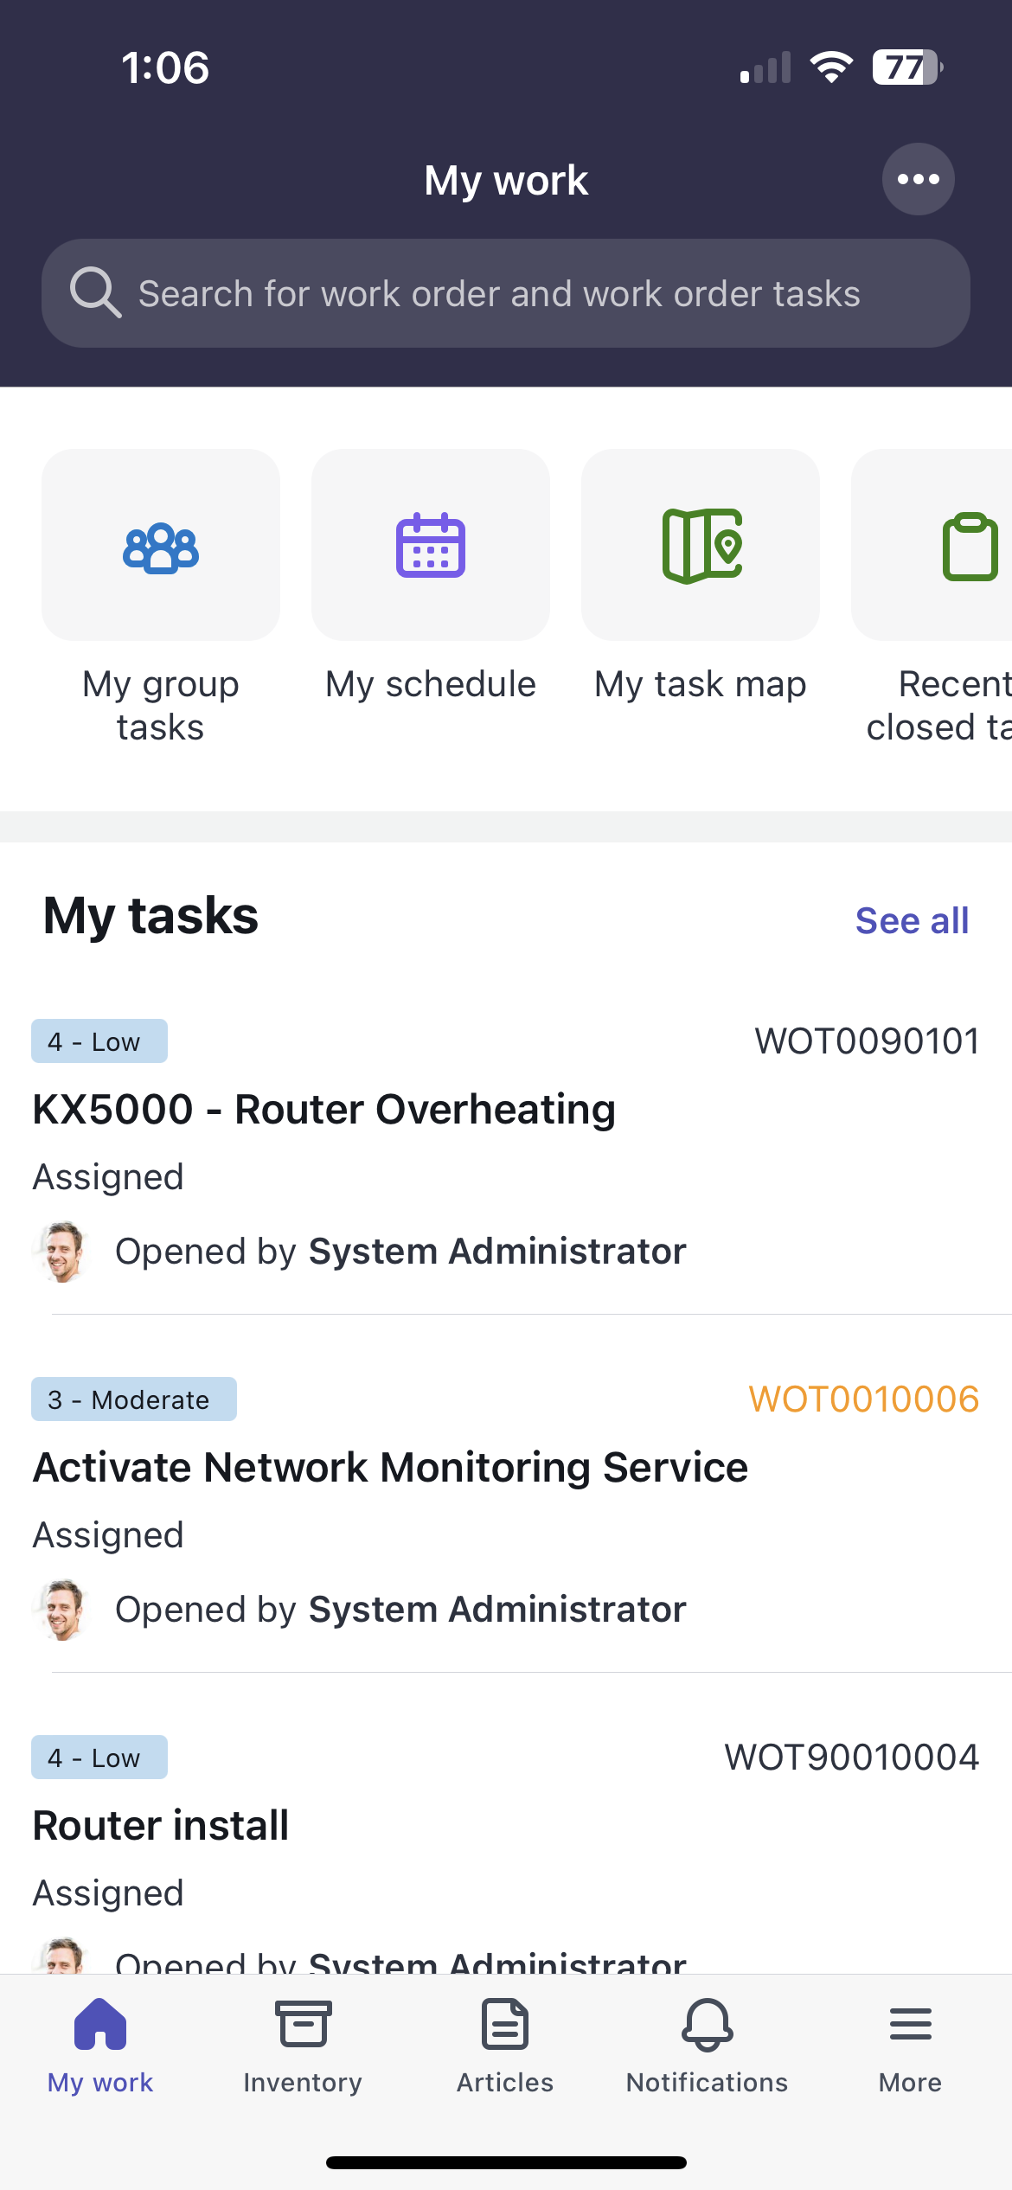

Section 3.2 Changing icons on a record section

1. Go back to your browser tab with **Mobile App Builder** and click on the ‘**home’** icon   
     
     
     
   This should return you to the home screen of your field service mobile application scope  
     
   
2. On the **All mobile records category**, search and open the following:
   1. **Record type**: Icon Section [sys_sg_navigation_section]
   2. **Search**: My Work ALP top nav section

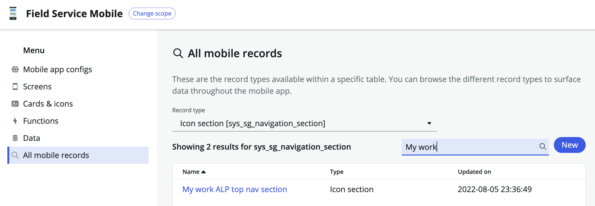

1. Scroll down to the **icon section destination** of the config panel and open ‘**My group tasks’**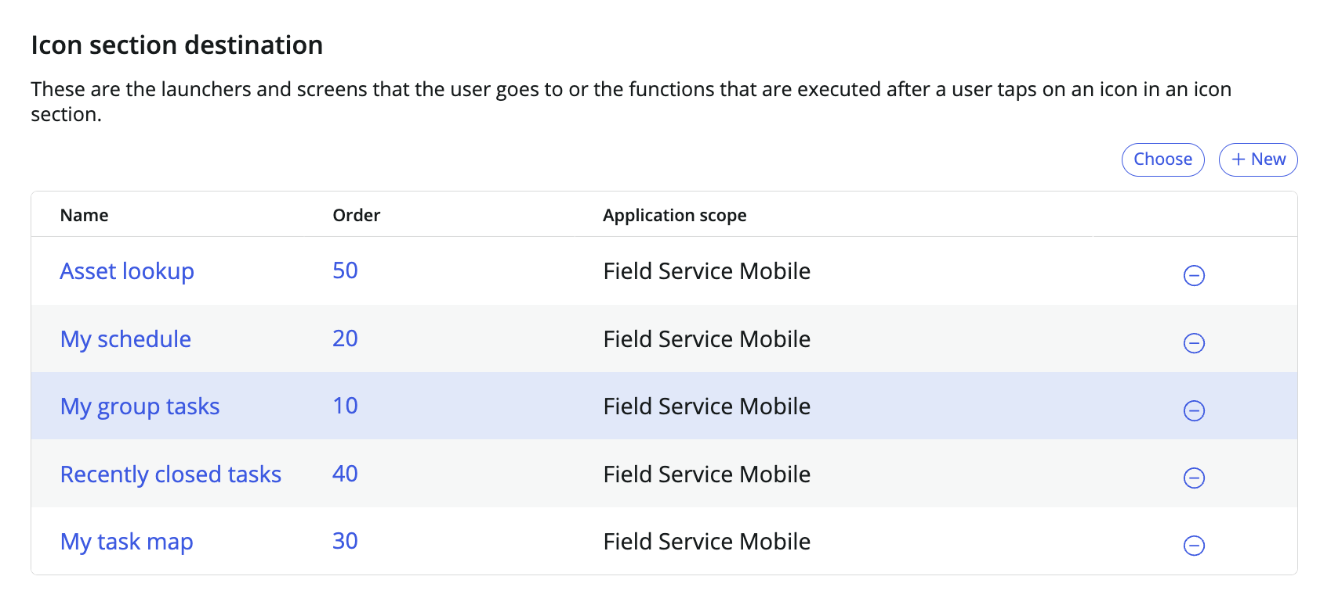
2. Under the icon table, click on the ‘-‘ icon to remove the pre-existing icon record  
     
   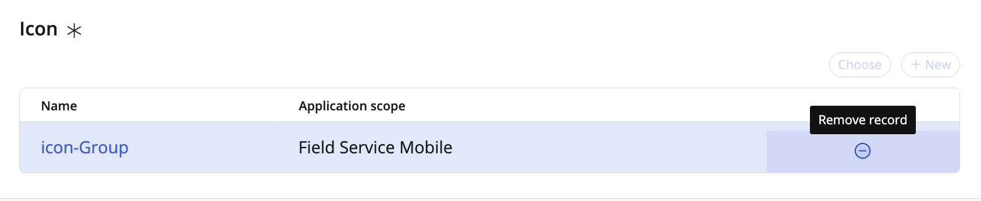
3. Click on ‘**choose’** next to the icon table



1. Search and open ‘**icon-Wrench’** and click ‘**apply’**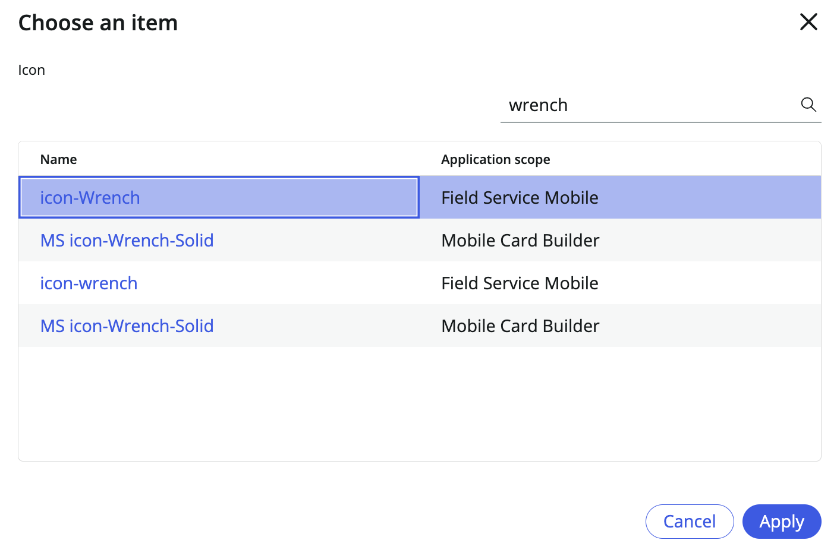
2. On the top right of your ‘Icon Section Destination Screen’, click ‘**save’**
3. Open up the ServiceNow Agent app and refresh (swipe your finger from top down) your ‘My Work’ screen launcher tab to update all of your changes.

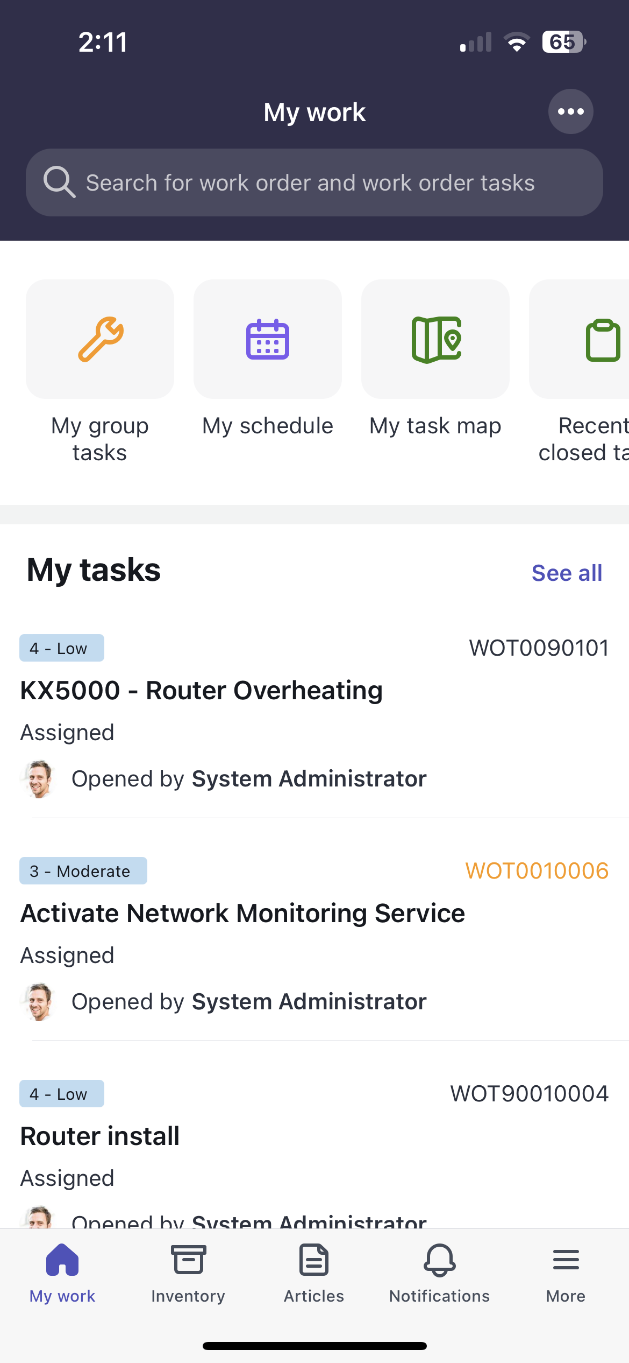

Section 4 Configuring an icon section with custom images

Section 4.1 Download custom images

1. Download the following files below: (save image as .png or take a screenshot)

 

**Filename**: Landing.png **Filename**: Astro.png

 

**Filename**: Flying.png **Filename**: Post.png

You can use unique file names so that it is easier to find later

Section 4.2 Uploading custom images

1. Open up a new tab of your instance’s home page  
     
   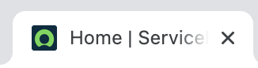
2. Click on the ‘**All’** tab, type and open up **‘sys_sg_icon_image.list’**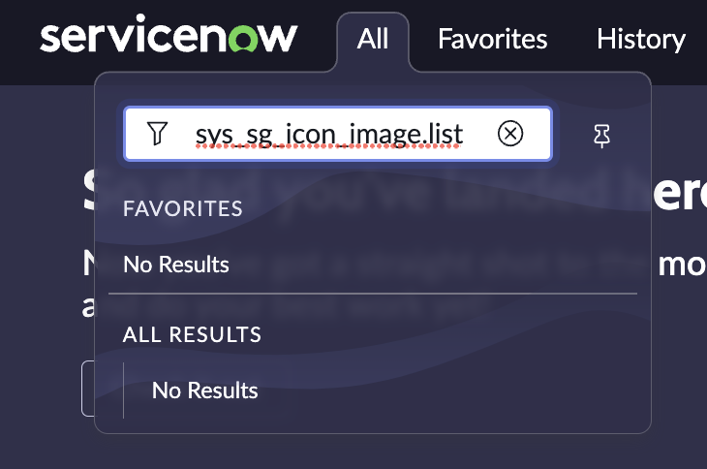

This is a table where you can upload custom images for your icon sections

1. Click ‘**new’** at the top right to create a new icon image  
     
   
2. Fill in and upload the following:

**Name**: Landing

**Image**: Landing.png  
  
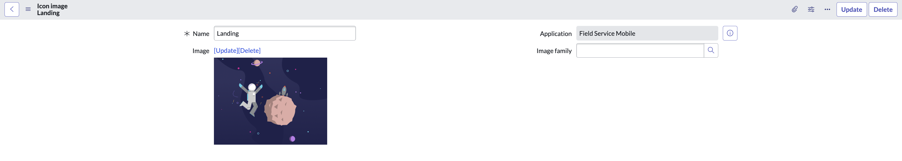  
Click ‘**update’** when done.

1. Click ‘**new’** at the top right to create a new icon image  
     
   
2. Fill in and upload the following:

**Name**: Astro

**Image**: Astro.png  
  
  
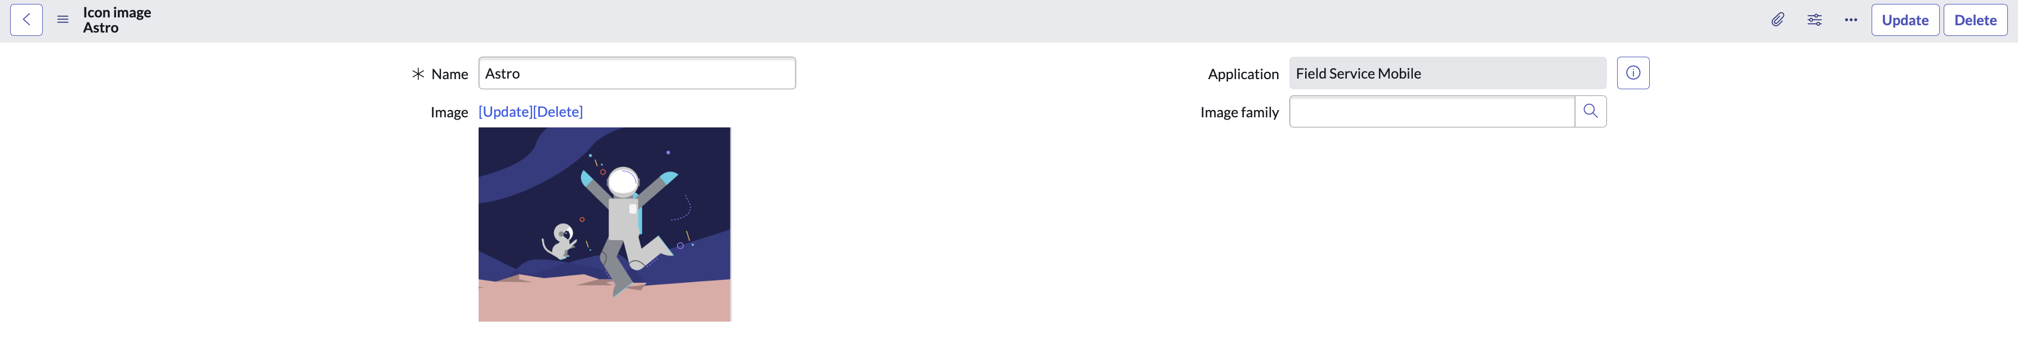  
Click ‘**update’** when done.

1. Click ‘**new’** at the top right to create a new icon image  
     
   
2. Fill in and upload the following:

**Name**: Flying

**Image**: Flying.png  
  
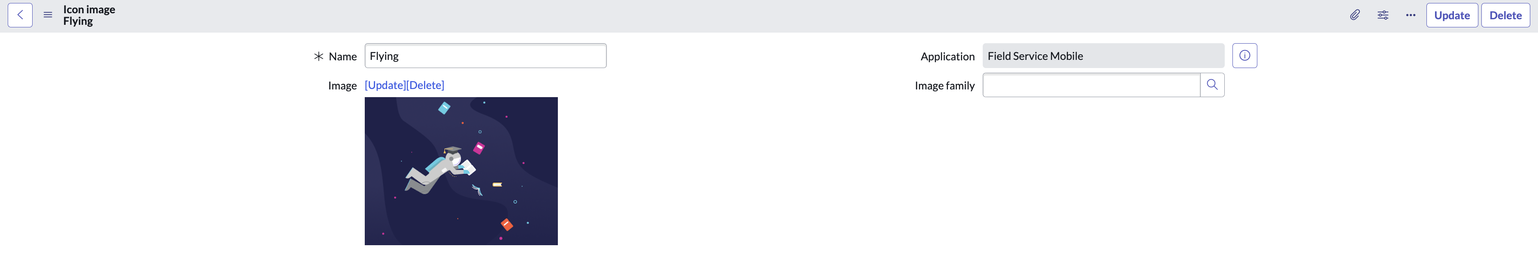  
Click ‘**update’** when done.

1. Click ‘**new’** at the top right to create a new icon image  
     
   
2. Fill in and upload the following:

**Name**: Post

**Image**: Post.png  
  
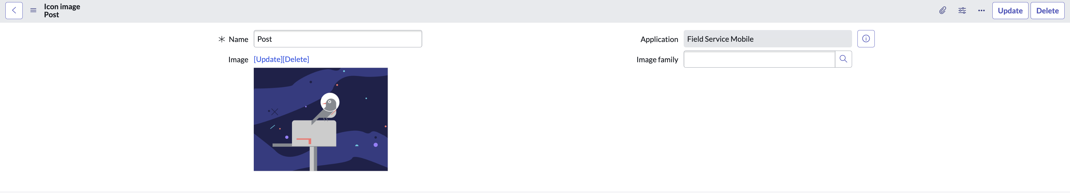  
Click ‘**update’** when done.

1. Copy and paste the sysID of each record to save for later (click on the hamburger icon)

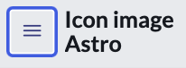  
  
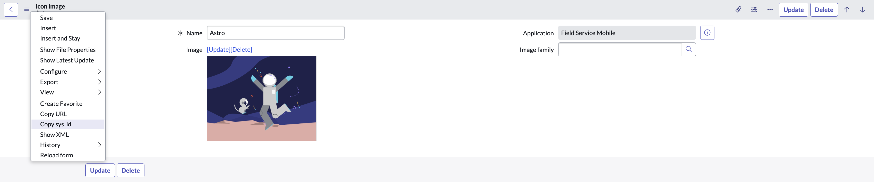

**Landing SysID**: e4fdbc1271f261107f440544f0bff446 [replace with your own sysID)

**Astro SysID**: bd1efc1271f261107f440544f0bff4d7 [replace with your own sysID)

**Flying SysID**: 644ef4de71b261107f440544f0bff49f [replace with your own sysID)

**Post SysID**: 095ebc1271f261107f440544f0bff4e1 [replace with your own sysID)

You will have a unique sysID so make sure to copy your own and save it for later

Section 4.3 Configuring a new icon section

1. Go back to your browser tab with **Mobile App Builder** and click on the ‘**home’** icon   
     
   
2. This should return you to the home screen of your field service mobile application scope  
     
   
3. On the **All mobile records category**, search and open the following:
   1. **Record type**: Icon Section [sys_sg_navigation_section]

Click on ‘**new’** to create a new icon section  
  
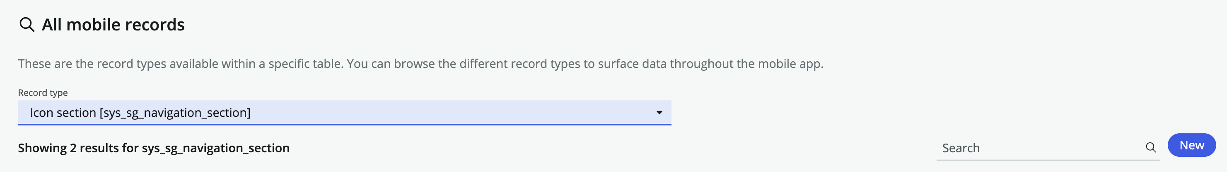

1. Fill in the following fields:

**Properties**

**Name**: Custom Image Icon Section

**Active**: True

1. **Settings**

**Hide header**: True

**Orientation**: Vertical

**Display type**: Image

**Number of columns**: 1

**Number of columns for landscape mode or tablet**: 1

**Display feed count**: False

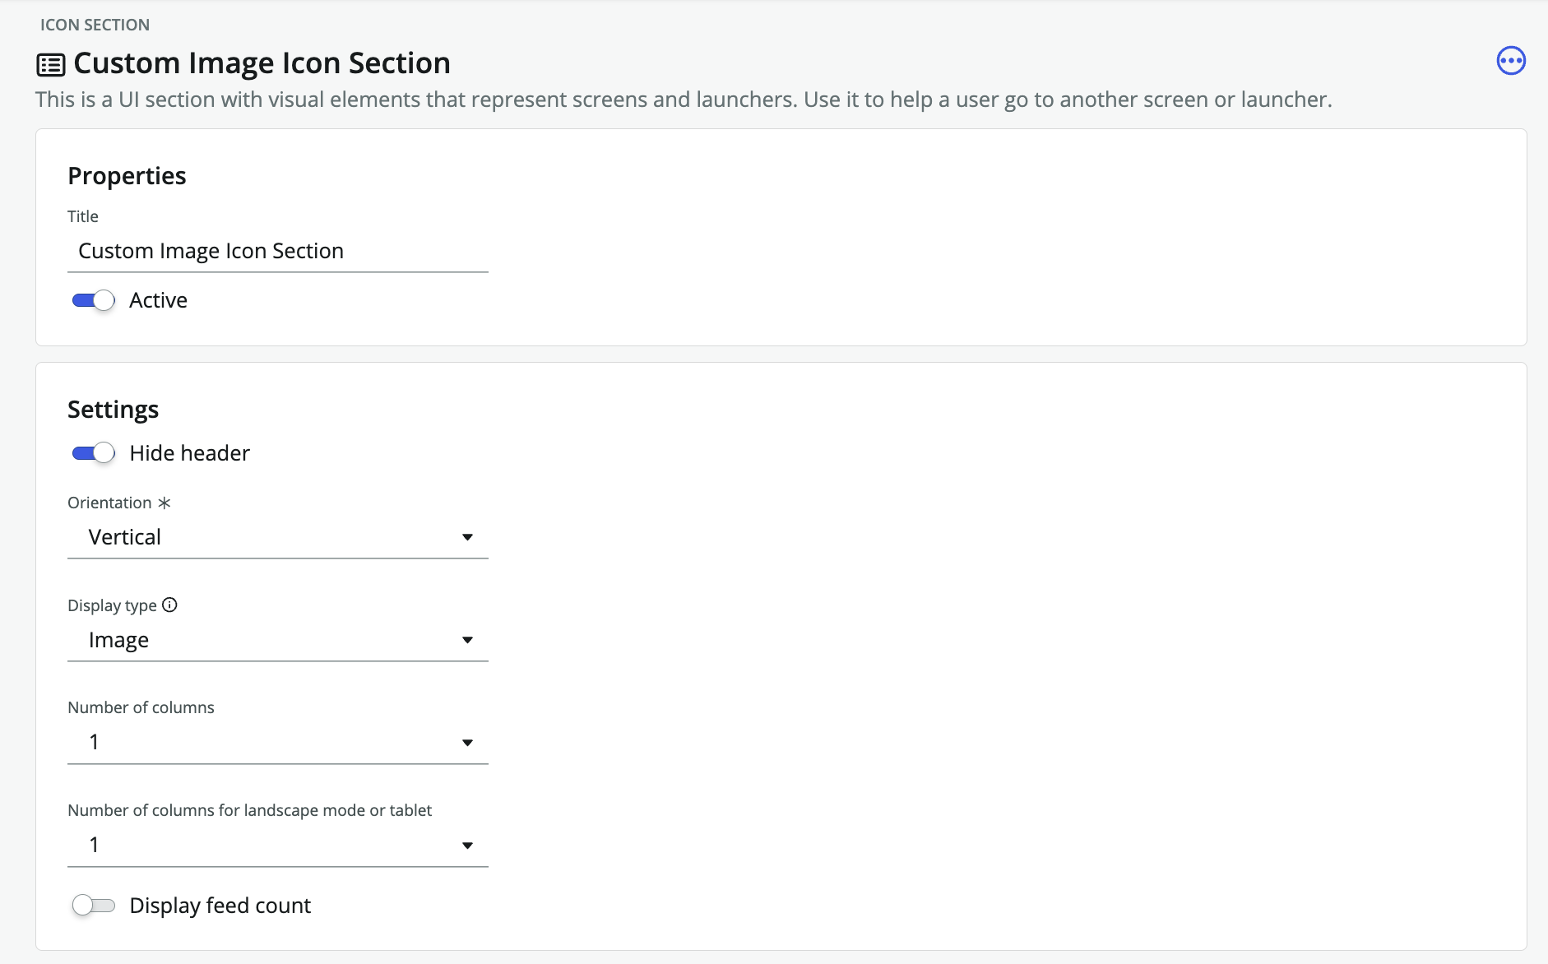

Click ‘**save’** at the top right of your icon section when done  
  


1. Under **icon section destination**, click ‘**+ New**’ icon to create a new record  
     
   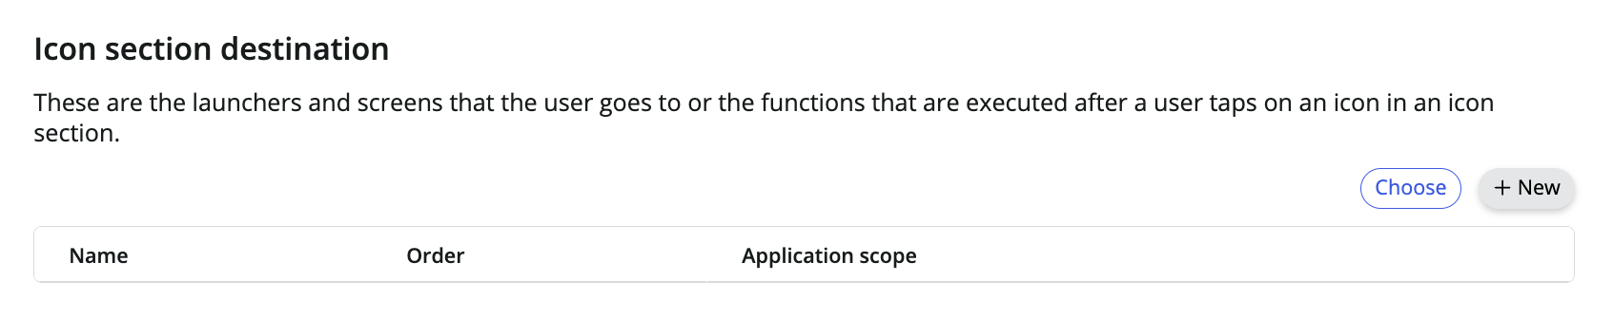
2. Select ‘**screen’** and click **continue**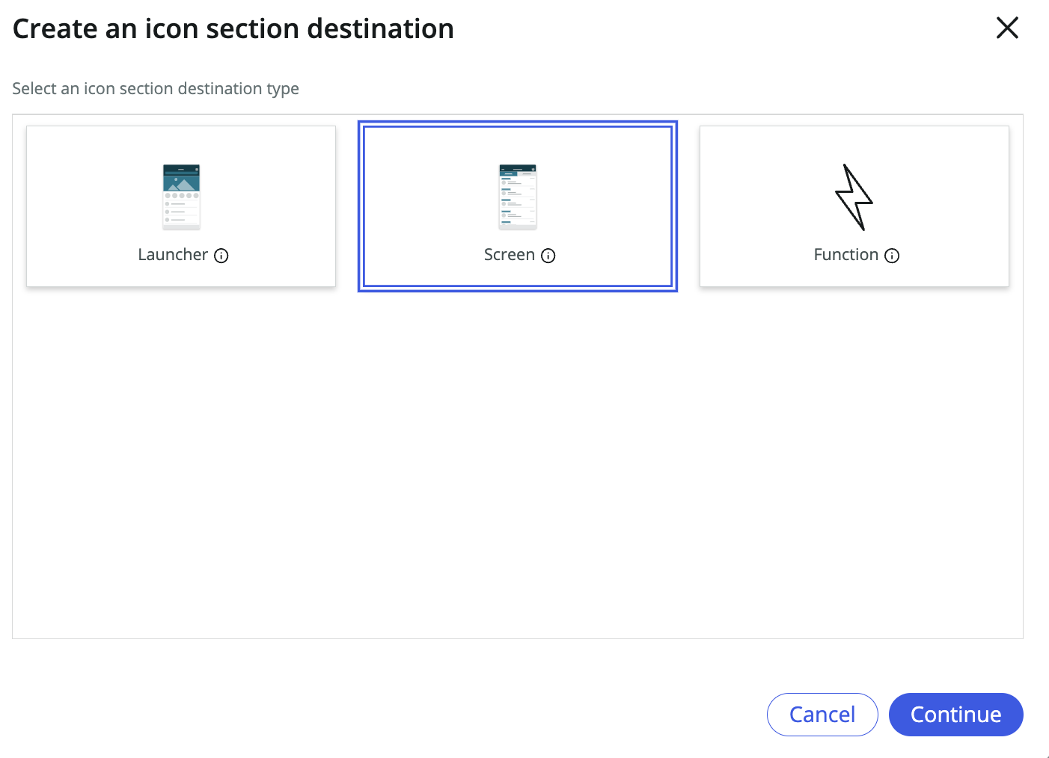
3. Select and fill in the following fields:  
     
   **Name**: My Group Tasks

**Screen**: My Group Tasks

**Icon**: Icon-Clipboard (Icon will not matter since we are using a custom image)

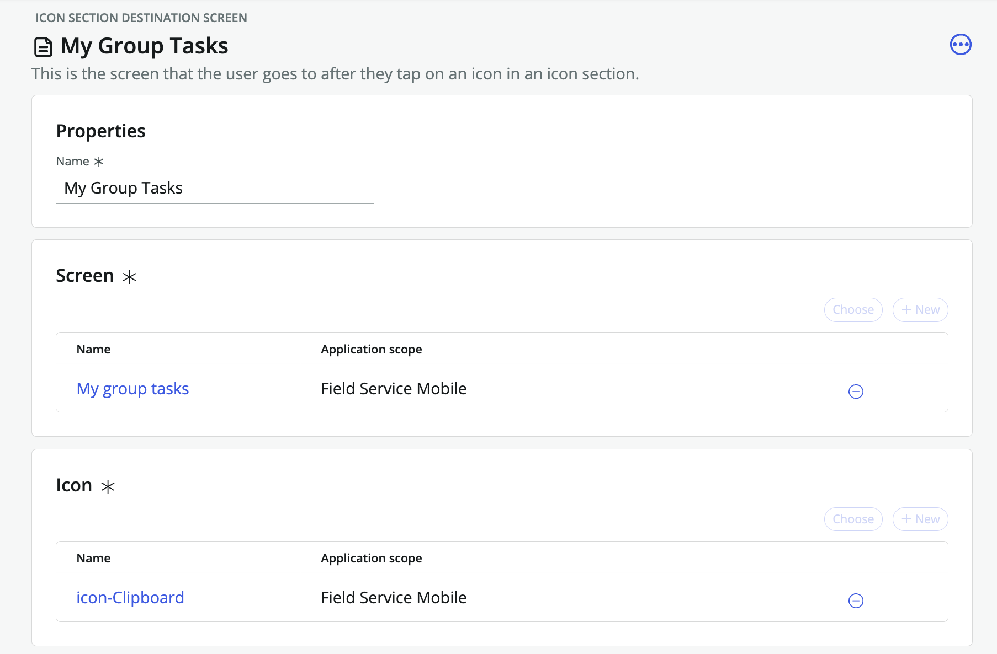

1. Click ‘**save’** at the top right of icon section destination screen  
     
   
2. Under image, click ‘**new’** to create a new image.  
     
   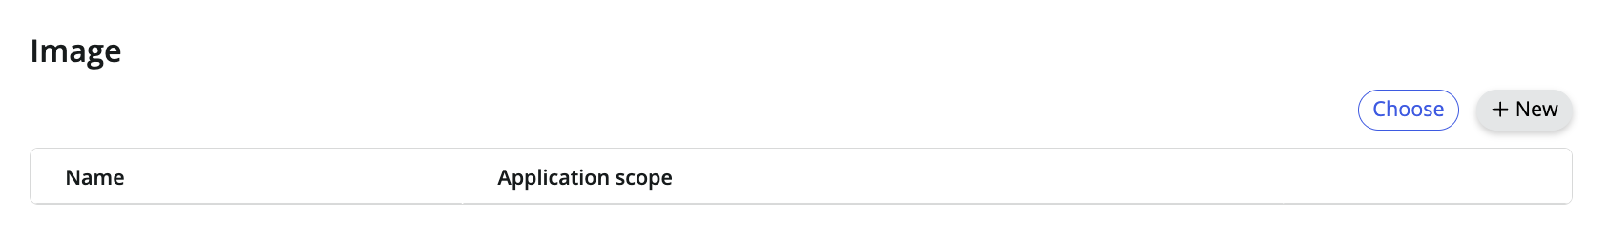
3. Fill in the following fields:

**Properties**

* Name: Landing
* Type: Image

**Set Appearance**

Style: ImageRef

Value: e4fdbc1271f261107f440544f0bff446 (your sysID you copied earlier)

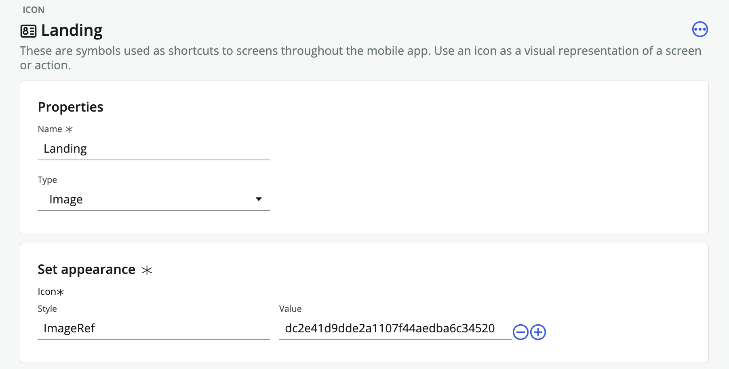

1. Click ‘**save’** at the top right of your icon when done  
     
   
2. On your left-hand configuration tree, scroll up to the top and open up ‘**Custom Image Icon Section’**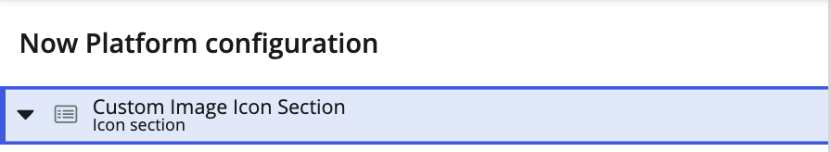

This will return you to your icon destination screen so that you can create another image icon



1. Under **icon section destination**, click ‘**+ New**’ icon to create a new record  
     
   
2. Select ‘**screen’** and click **continue**
3. Select and fill in the following fields:  
     
   **Name**: My Schedule

**Screen**: My Schedule

**Icon**: Icon-Clipboard (Icon will not matter since we are using a custom image)

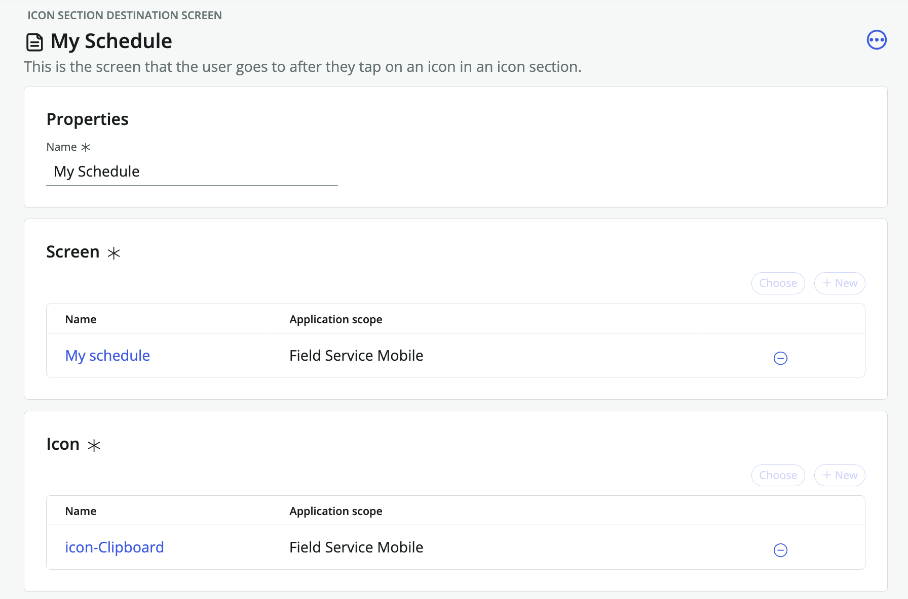

1. Click ‘**save’** at the top right of icon section destination screen  
     
   
2. Under image, click ‘+ **new’** to create a new image.  
     
   
3. Fill in the following fields:

**Properties**

* Name: Astro
* Type: Image

**Set Appearance**

Style: ImageRef

Value: bd1efc1271f261107f440544f0bff4d7 (your sysID you copied earlier)



1. Click ‘**save’** at the top right of your icon when done  
     
   
2. On your left-hand configuration tree, scroll up to the top and open up ‘**Custom Image Icon Section’**

This will return you to your icon destination screen so that you can create another image icon



1. Under **icon section destination**, click ‘**+ New**’ icon to create a new record  
     
   
2. Select ‘**screen’** and click **continue**
3. Select and fill in the following fields:  
     
   **Name**: My task map

**Screen**: My task map

**Icon**: Icon-Clipboard (Icon will not matter since we are using a custom image)

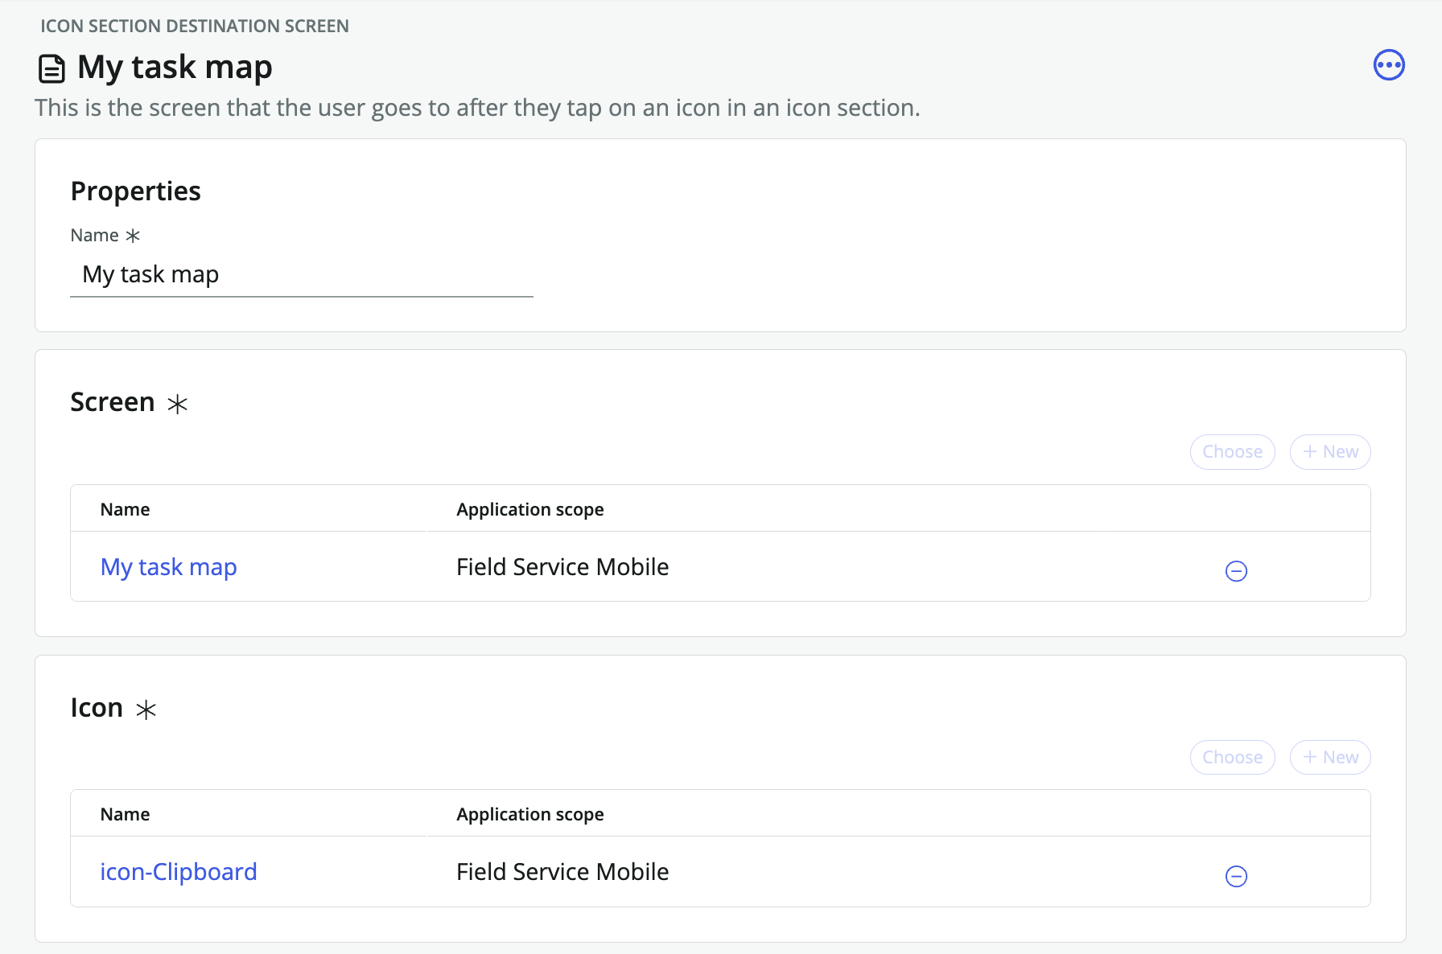

1. Click ‘**save’** at the top right of icon section destination screen  
     
   
2. Under image, click ‘+ **new’** to create a new image.  
     
   
3. Fill in the following fields:

**Properties**

* Name: Flying
* Type: Image

**Set Appearance**

Style: ImageRef

Value: 644ef4de71b261107f440544f0bff49f (your sysID you copied earlier)

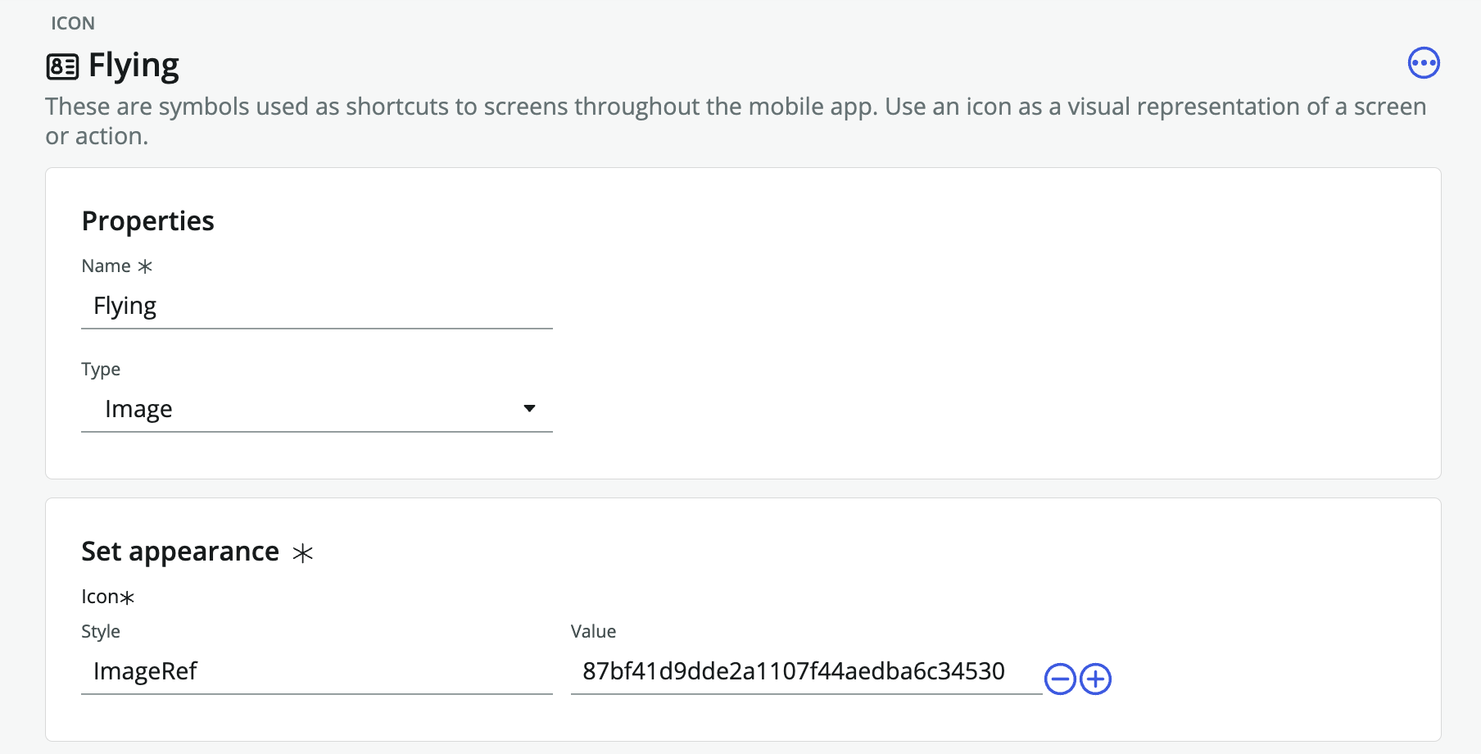

1. Click ‘**save’** at the top right of your icon when done  
     
   
2. On your left-hand configuration tree, scroll up to the top and open up ‘**Custom Image Icon Section’**

This will return you to your icon destination screen so that you can create another image icon



1. Under **icon section destination**, click ‘**+ New**’ icon to create a new record  
     
   
2. Select ‘**screen’** and click **continue**
3. Select and fill in the following fields:  
     
   **Name**: Recently closed tasks

**Screen**: Recently closed tasks

**Icon**: Icon-Clipboard (Icon will not matter since we are using a custom image)

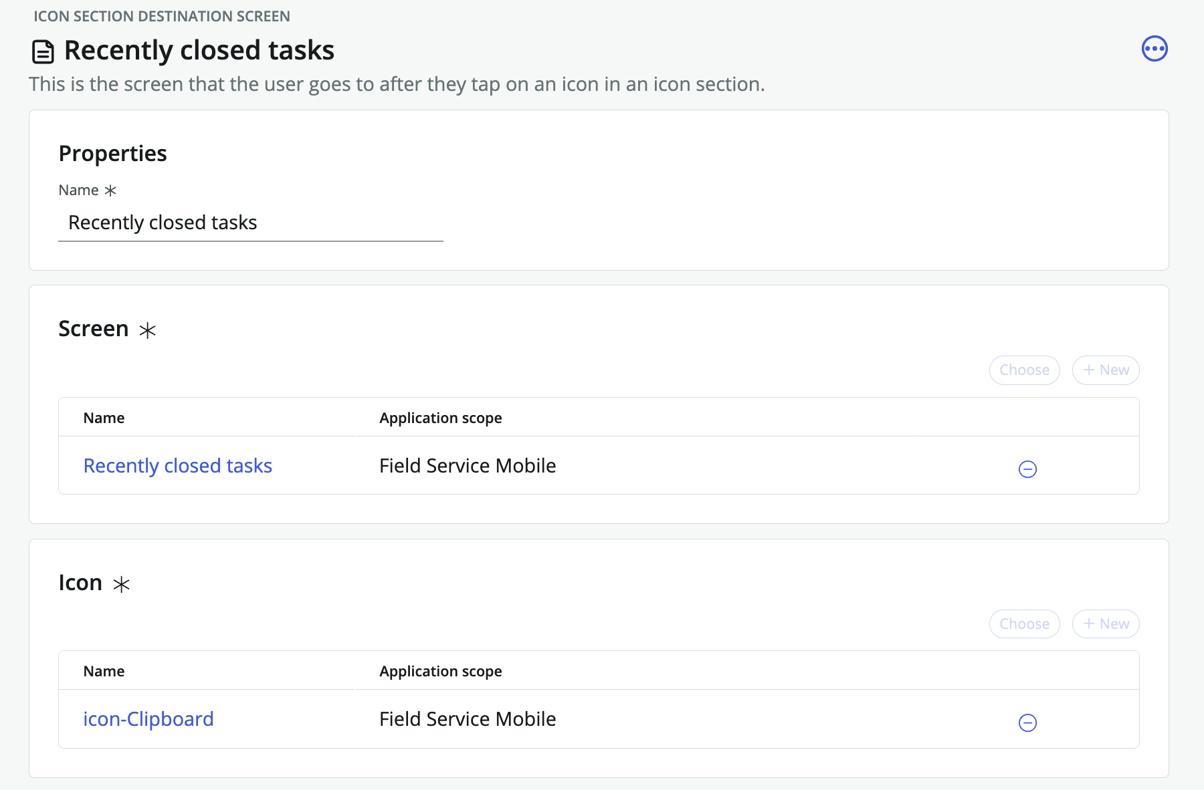

1. Click ‘**save’** at the top right of icon section destination screen  
     
   
2. Under image, click ‘+ **new’** to create a new image.  
     
   
3. Fill in the following fields:

**Properties**

* Name: Post
* Type: Image

**Set Appearance**

Style: ImageRef

Value: 095ebc1271f261107f440544f0bff4e1 (your sysID you copied earlier)

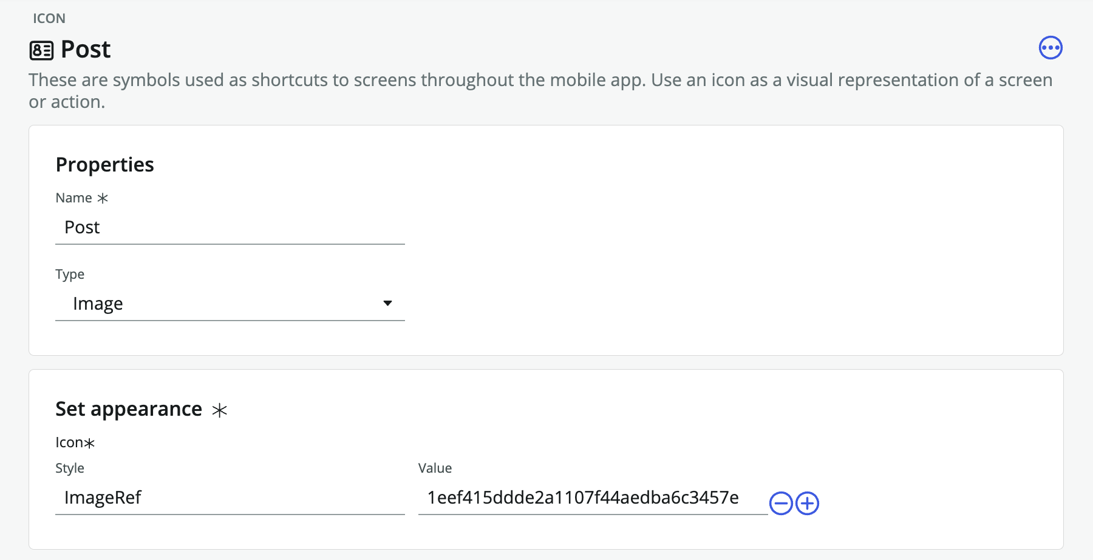

1. Click ‘**save’** at the top right of your icon when done  
     
   
2. On your left-hand configuration tree, scroll up to the top and open up ‘**Custom Image Icon Section’**

At this point you should have 4 icon section destinations created with your custom images

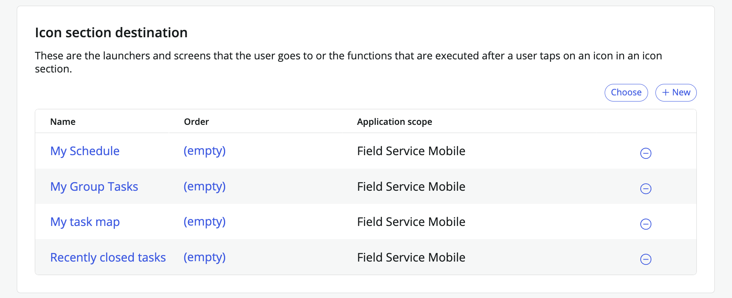

1. On your **Mobile App Builder** browser tab, click on the ‘**home’** icon   
     
   
2. This should return you to the home screen of your field service mobile application scope  
     
   
3. On the **Screens category**, search and open the following:
   1. **My Work** (launcher screen)

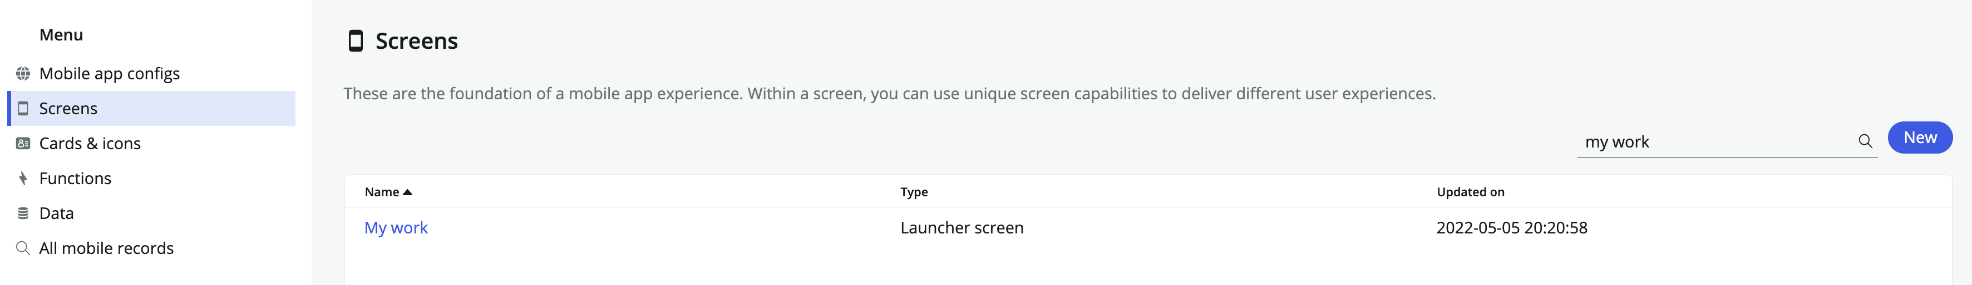

1. On the ‘My Work’ launcher screen configuration panel, scroll down to ‘**Launcher Section’** and click on the **‘-‘ icon** to remove ‘**My Work top icon section’** launcher section

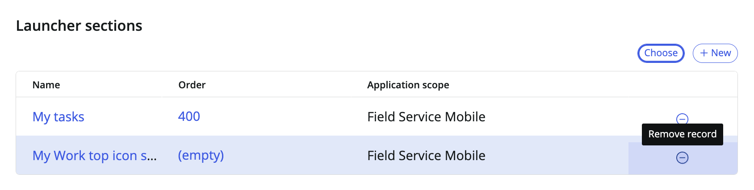

1. Click ‘**save’** at the top right of your launcher screen when done  
     
   
2. Under launcher sections, click on ‘choose’ to select the icon section we created earlier  
     
   
3. Search and open up ‘**Custom Image Icon Section’** and click ‘**apply’** when done  
     
   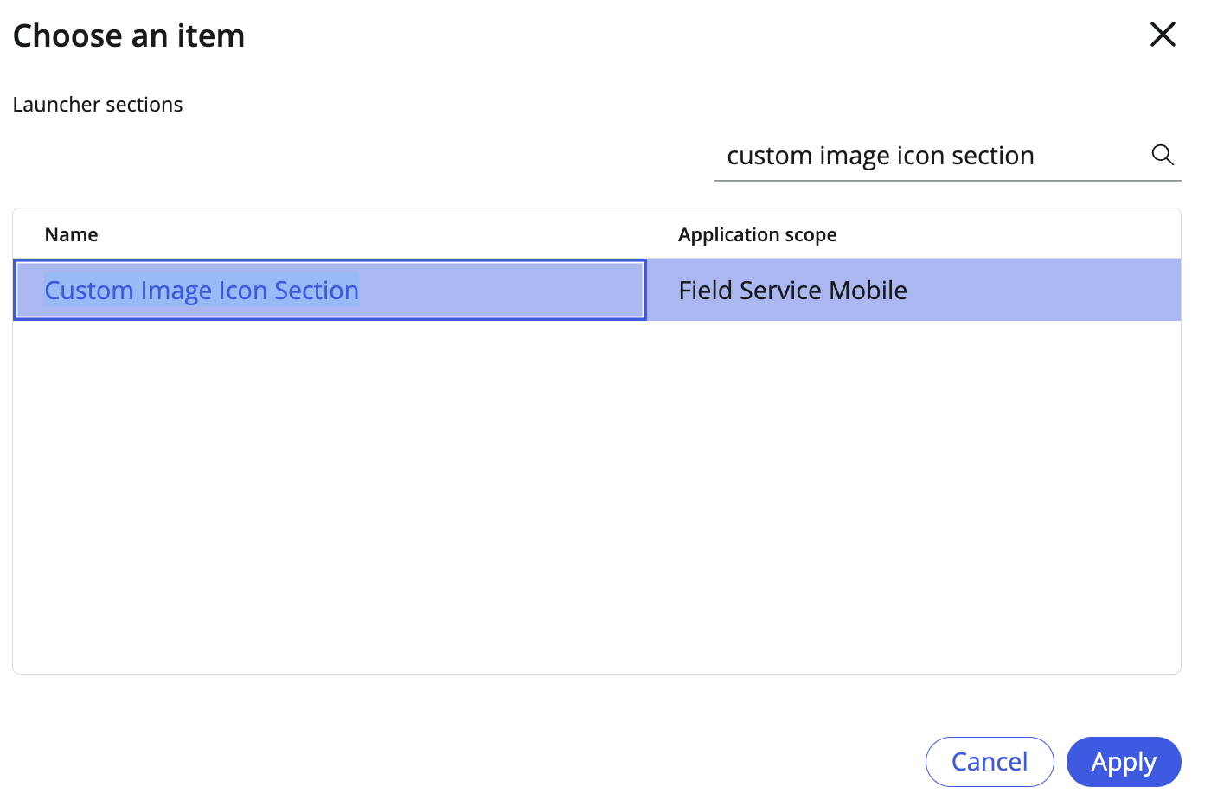
4. Click ‘**save’** at the top right of your launcher screen when done  
     
   
5. Open up the ServiceNow Agent app and refresh (swipe your finger from top down) your ‘My Work’ screen launcher tab to update all of your changes.

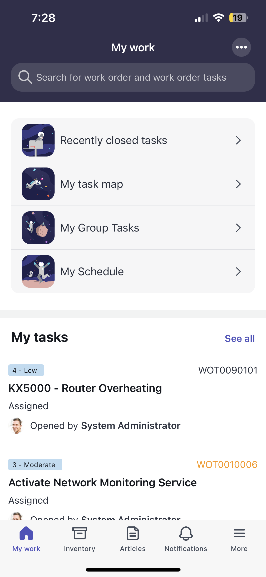

Section 5 Configuring a mobile banner

Section 5.1 Download mobile banner image

1. Download the following files below: (save image as .png)



**Filename**: Velox.png

The image should have a height of 160px and width of 375px, resize if needed

Section 5.2 Configuring a media section

1. Go back to your browser tab with **Mobile App Builder** and click on the ‘**home’** icon   
     
   
2. This should return you to the home screen of your field service mobile application scope  
     
   
3. On the **screens category**, search and open the ‘**My work’** launcher screen  
     
   
4. On the launcher screen configuration panel, scroll down to ‘**Launcher sections’** and click ‘**+new’** to create a new media section  
     
   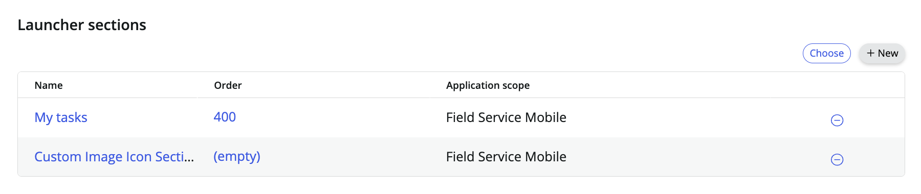
5. Select ‘**Media’** and click ‘**continue’**  
     
   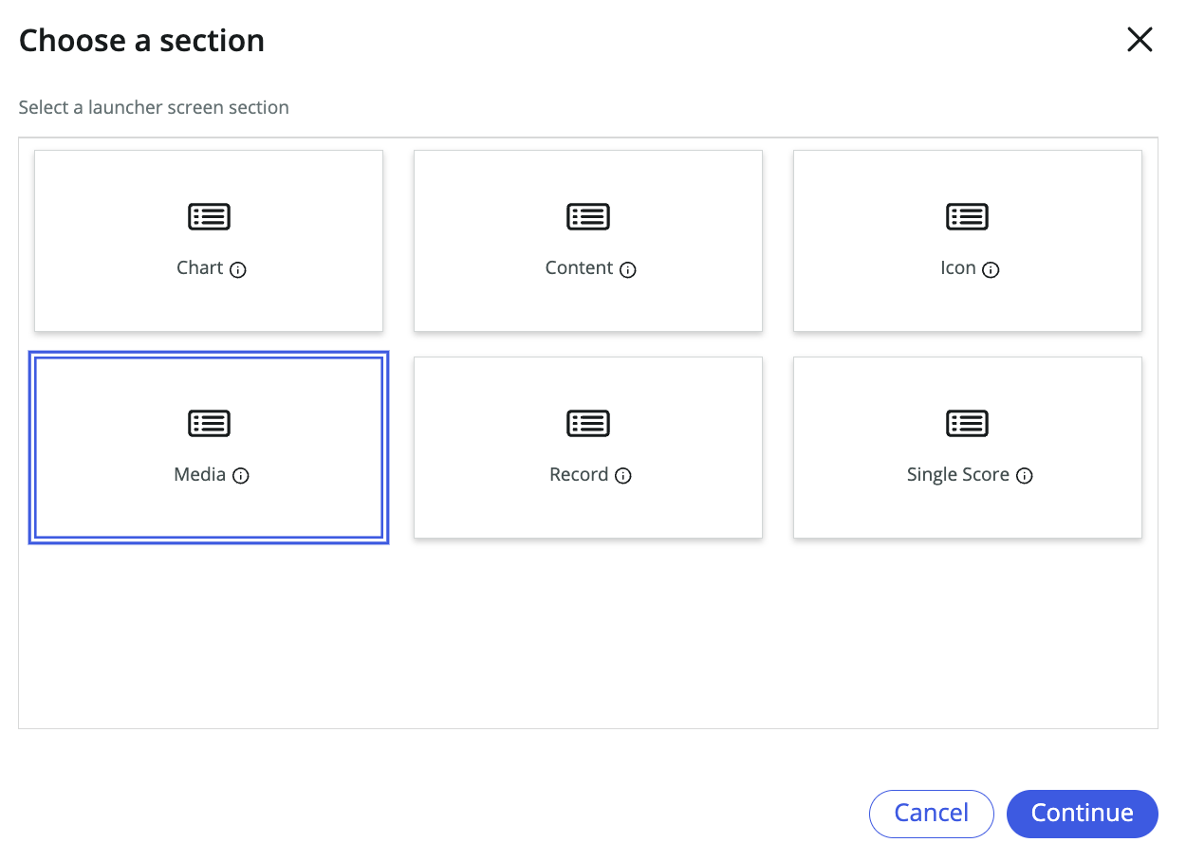
6. Select and fill in the following fields:  
     
   **Title**: Velox

**Headline**: The world works better with Velox

**Text**: Our digital experiences can help your organization, so it simply works better

**Type**: Image

**Media**: Velox.png (Your saved image should be 160x375 pixels)

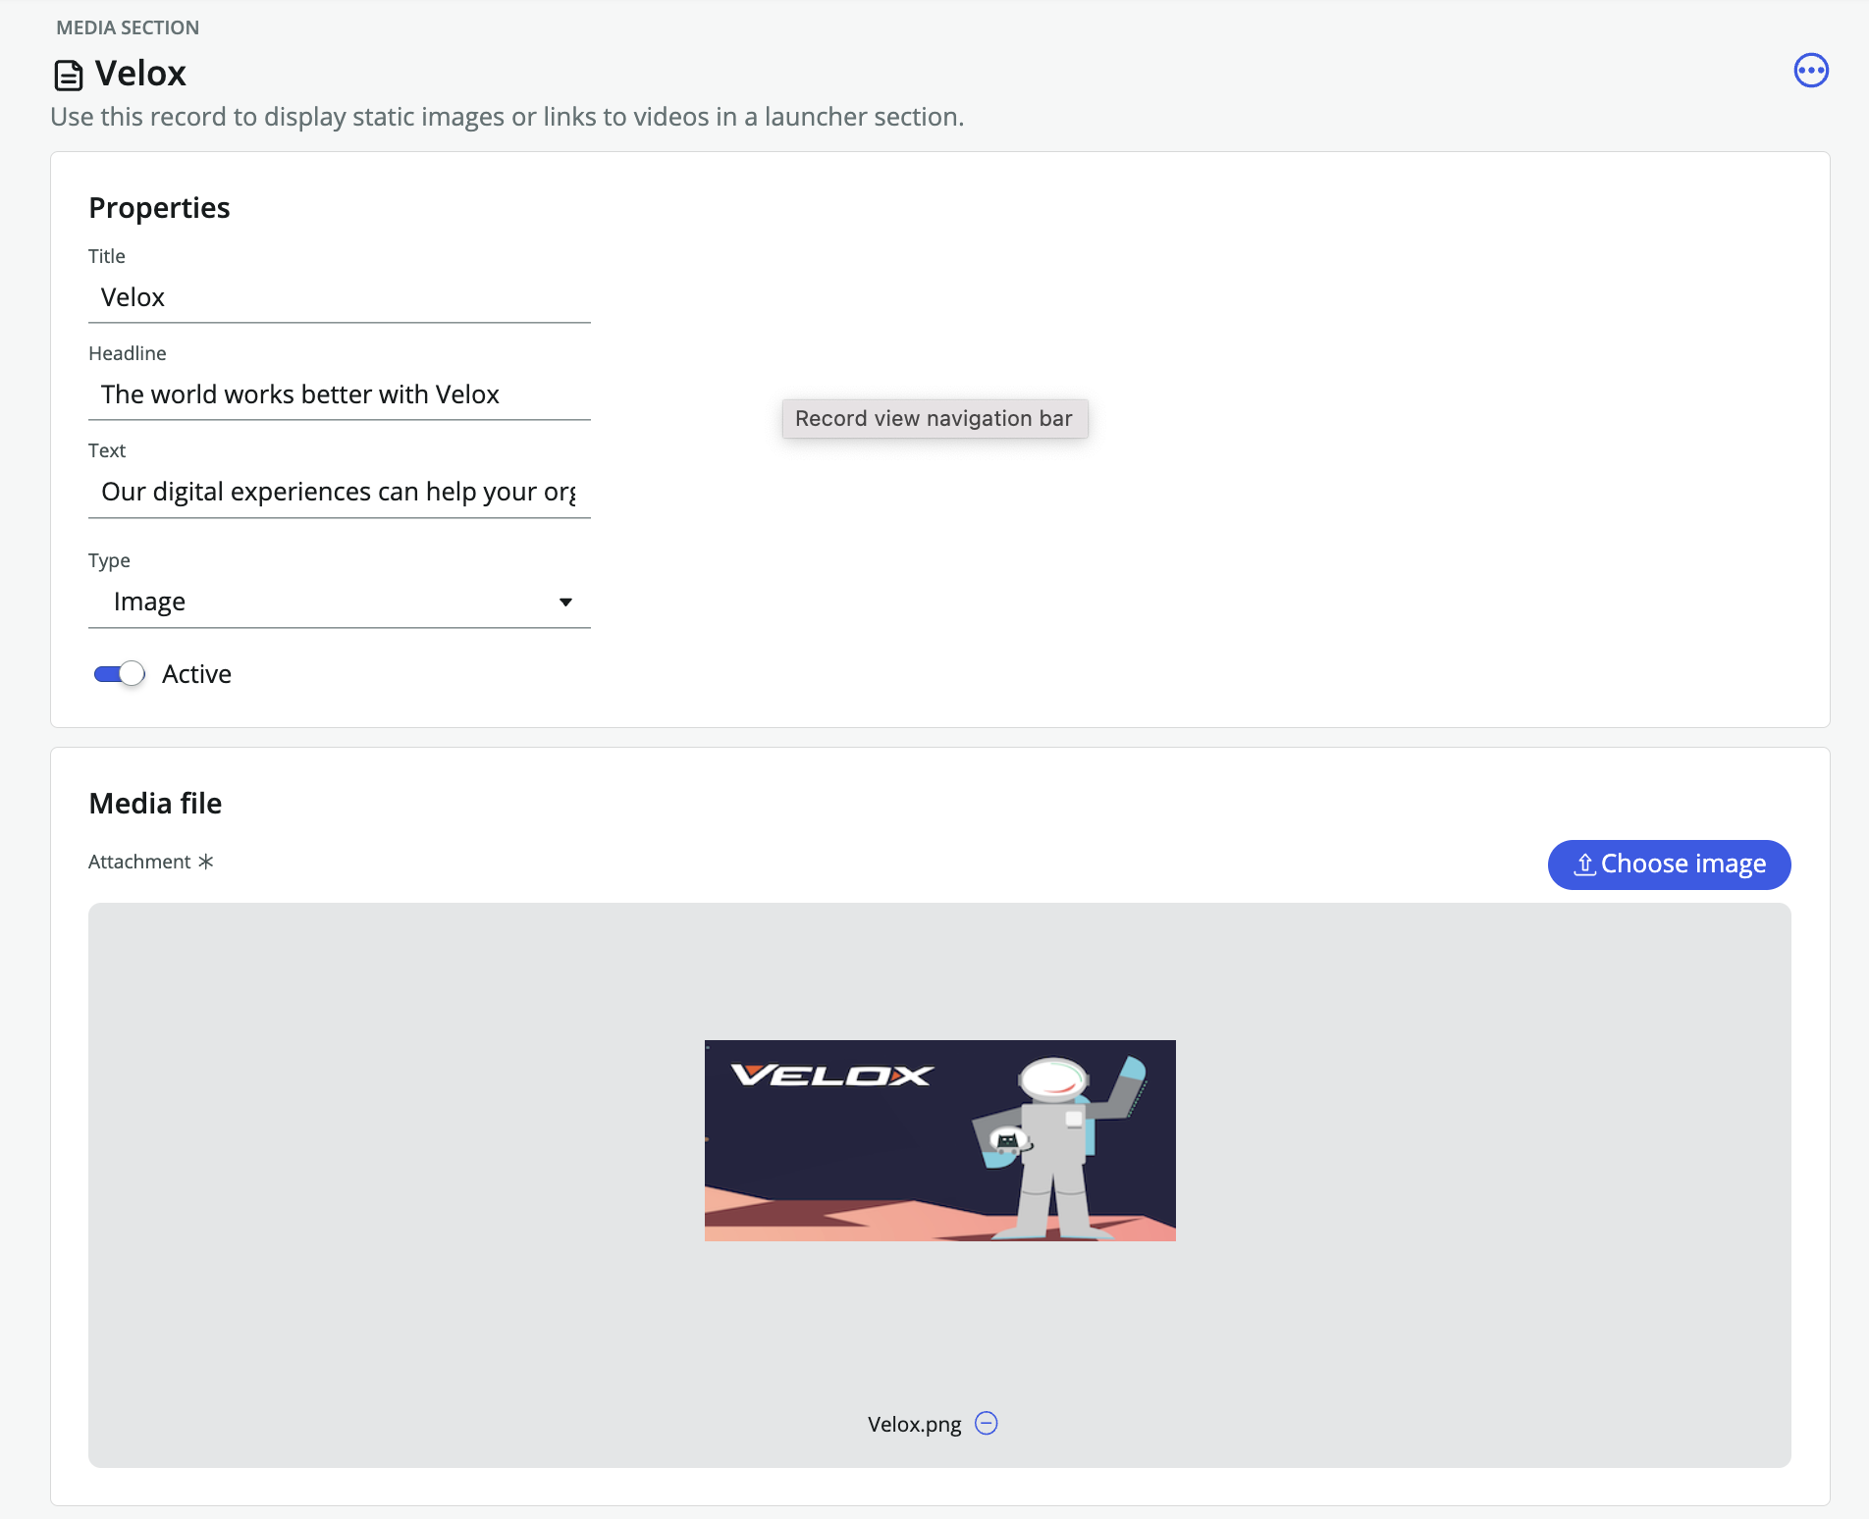

1. Click ‘**save’** at the top right of your media section  
     
   
2. Open up the ServiceNow Agent app and refresh (swipe your finger from top down) your ‘My Work’ screen launcher tab to update all of your changes.

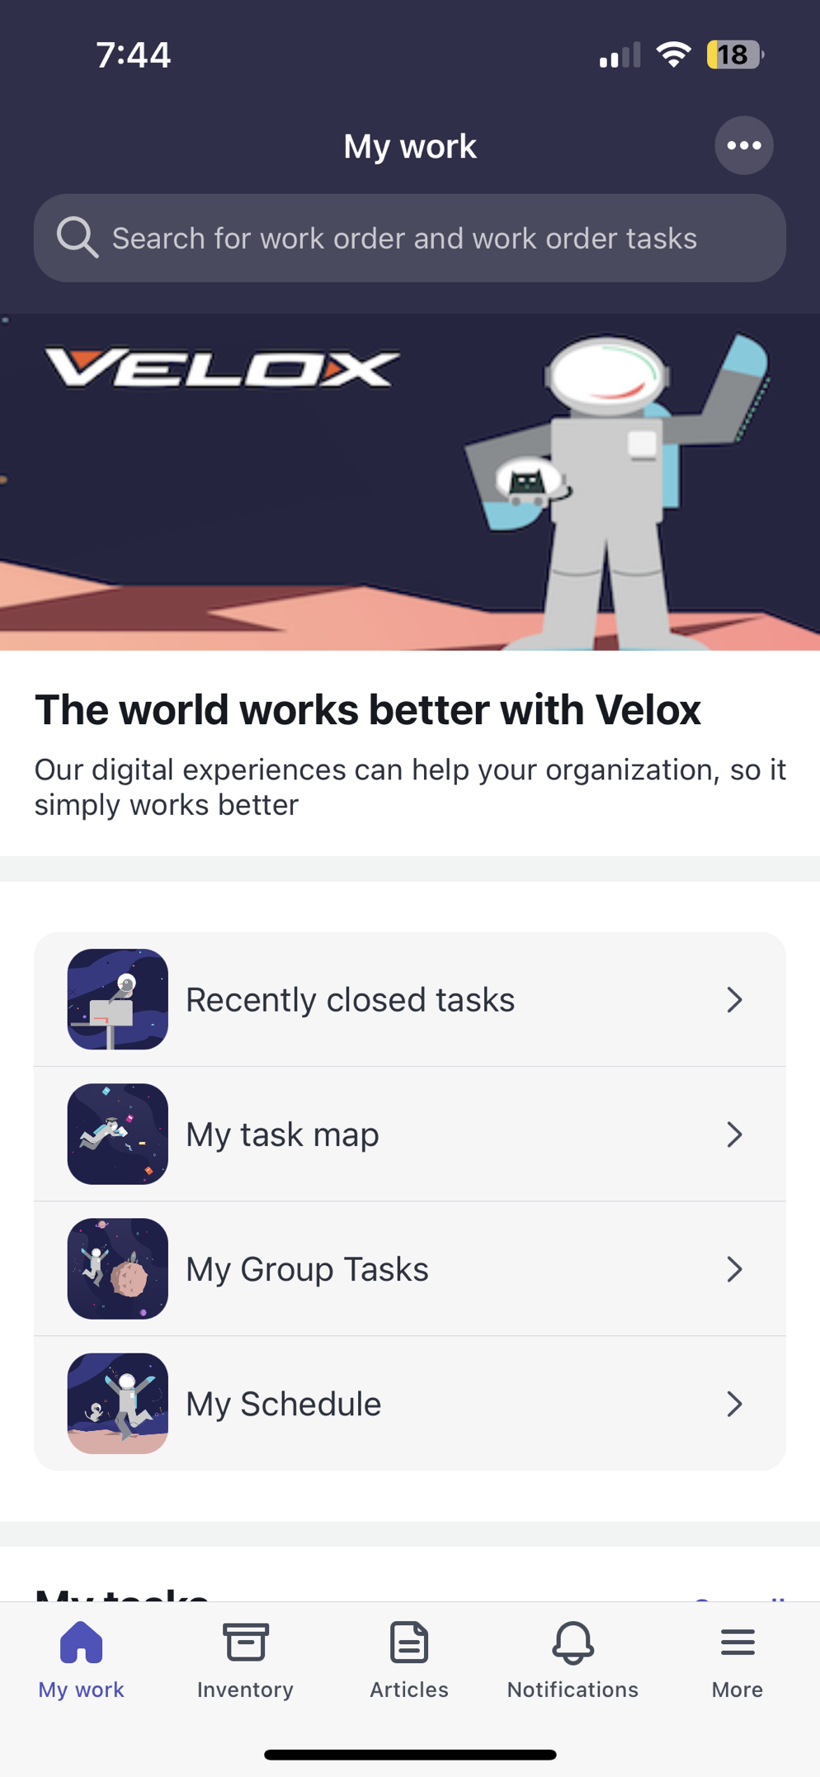

**Congratulations! You have completed this lab.**